DS1230Y/AB 256k Nonvolatile SRAM

FEATURES
▪ 10 years minimum data retention in the
PIN ASSIGNMENT

A14 1
28 VCC

absence of external power
▪ Data is automatically protected during power loss
▪ Replaces 32k x 8 volatile static RAM, EEPROM or Flash memory
▪ Unlimited write cycles
▪ Low-power CMOS
▪ Read and write access times as fast as 70 ns
▪ Lithium energy source is electrically disconnected to retain freshness until power is applied for the first time
A12 2
A7 3
A6 4
A5 5
A4 6
A3 7
A2 8
A1 9
A0 10
DQ0 11
DQ1 12
DQ2 13
GND 14
27 WE
26 A13
25 A8
24 A9
23 A11
22 OE
21 A10
20 CE
19 DQ7
18 DQ6
17
DQ5
16 DQ4
15 DQ3

▪ Full ±10% VCC operating range (DS1230Y)
▪ Optional ±5% VCC operating range
(DS1230AB)
▪ Optional industrial temperature range of

28-Pin ENCAPSULATED PACKAGE
740-mil EXTENDED

-40°C to +85°C, designated IND
▪ JEDEC standard 28-pin DIP package
▪ PowerCap Module (PCM) package
- Directly surface-mountable module
NC 1
NC 2
NC 3
NC 4
VCC 5
WE 6
OE 7
34 NC
33 NC
32 A14
31 A13
30 A12
29 A11
28 A10

- Replaceable snap-on PowerCap provides lithium backup battery
- Standardized pinout for all nonvolatile
SRAM products
- Detachment feature on PowerCap allows
CE DQ7
DQ6
DQ5
DQ4
DQ3
DQ2
DQ1
DQ0
GND
8
9
10
11
12
13 GND
14
15
16
17

VBAT
27 A9
26 A8
25 A7
24 A6
23 A5
22 A4
21 A3
20 A2
19 A1
18 A0

easy removal using a regular screwdriver

34-Pin POWERCAP MODULE (PCM) (USES DS9034PC POWERCAP)

PIN DESCRIPTION
A0 - A14 - Address Inputs
DQ0 - DQ7 - Data In/Data Out
CE - Chip Enable WE - Write Enable OE - Output Enable VCC - Power (+5V) GND - Ground
NC - No Connect

1 of 13 121907

DESCRIPTION
DS1230Y/AB
The DS1230 256k Nonvolatile SRAMs are 262,144-bit, fully static, nonvolatile SRAMs organized as
32,768 words by 8 bits. Each NV SRAM has a self-contained lithium energy source and control circuitry which constantly monitors VCC for an out-of-tolerance condition. When such a condition occurs, the lithium energy source is automatically switched on and write protection is unconditionally enabled to prevent data corruption. DIP-package DS1230 devices can be used in place of existing 32k x 8 static RAMs directly conforming to the popular bytewide 28-pin DIP standard. The DIP devices also match the pinout of 28256 EEPROMs, allowing direct substitution while enhancing performance. DS1230 devices in the Low Profile Module package are specifically designed for surface-mount applications. There is no limit on the number of write cycles that can be executed and no additional support circuitry is required for microprocessor interfacing.

READ MODE
The DS1230 devices execute a read cycle whenever WE (Write Enable) is inactive (high) and CE (Chip Enable) and OE (Output Enable) are active (low). The unique address specified by the 15 address inputs (A0 - A14) defines which of the 32,768 bytes of data is to be accessed. Valid data will be available to the eight data output drivers within tACC (Access Time) after the last address input signal is stable, providing that CE and OE (Output Enable) access times are also satisfied. If OE and CE access times are not satisfied, then data access must be measured from the later-occurring signal ( CE or OE ) and the limiting parameter is either tCO for CE or tOE for OE rather than address access.

WRITE MODE
The DS1230 devices execute a write cycle whenever the WE and CE signals are active (low) after address inputs are stable. The later-occurring falling edge of CE or WE will determine the start of the write cycle. The write cycle is terminated by the earlier rising edge of CE or WE . All address inputs must be kept valid throughout the write cycle. WE must return to the high state for a minimum recovery time (tWR) before another cycle can be initiated. The OE control signal should be kept inactive (high) during write cycles to avoid bus contention. However, if the output drivers are enabled ( CE and OE active) then WE will disable the outputs in tODW from its falling edge.

DATA RETENTION MODE
The DS1230AB provides full functional capability for VCC greater than 4.75 volts and write protects by
4.5 volts. The DS1230Y provides full functional capability for VCC greater than 4.5 volts and write
protects by 4.25 volts. Data is maintained in the absence of VCC without any additional support circuitry.
The nonvolatile static RAMs constantly monitor VCC. Should the supply voltage decay, the NV SRAMs
automatically write protect themselves, all inputs become “don’t care,” and all outputs become high-
impedance. As VCC falls below approximately 3.0 volts, a power switching circuit connects the lithium energy source to RAM to retain data. During power-up, when VCC rises above approximately 3.0 volts the power switching circuit connects external VCC to RAM and disconnects the lithium energy source. Normal RAM operation can resume after VCC exceeds 4.75 volts for the DS1230AB and 4.5 volts for the DS1230Y.

FRESHNESS SEAL
Each DS1230 device is shipped from Dallas Semiconductor with its lithium energy source disconnected, guaranteeing full energy capacity. When VCC is first applied at a level greater than 4.25 volts, the lithium energy source is enabled for battery back-up operation.

2 of 13

PACKAGES
DS1230Y/AB
The DS1230 devices are available in two packages: 28-pin DIP and 34-pin PowerCap Module (PCM). The 28-pin DIP integrates a lithium battery, an SRAM memory and a nonvolatile control function into a single package with a JEDEC-standard, 600-mil DIP pinout. The 34-pin PowerCap Module integrates SRAM memory and nonvolatile control along with contacts for connection to the lithium battery in the DS9034PC PowerCap. The PowerCap Module package design allows a DS1230 PCM device to be surface mounted without subjecting its lithium backup battery to destructive high-temperature reflow soldering. After a DS1230 PCM is reflow soldered, a DS9034PC PowerCap is snapped on top of the PCM to form a complete Nonvolatile SRAM module. The DS9034PC is keyed to prevent improper attachment. DS1230 PowerCap Modules and DS9034PC PowerCaps are ordered separately and shipped in separate containers. See the DS9034PC data sheet for further information.

ABSOLUTE MAXIMUM RATINGS*
Voltage on Any Pin Relative to Ground -0.3V to +6.0V
Operating Temperature 0°C to 70°C, -40°C to +85°C for IND parts Storage Temperature -40°C to +70°C, -40°C to +85°C for IND parts Soldering Temperature
DIP Module +260°C for 10 seconds Caution: Do Not Reflow (Wave or Hand Solder Only) PowerCap Module See IPC/JEDEC J-STD-020

* This is a stress rating only and functional operation of the device at these or any other conditions above those indicated in the operation sections of this specification is not implied. Exposure to absolute maximum rating conditions for extended periods of time may affect reliability.

RECOMMENDED DC OPERATING CONDITIONS (tA: See Note 10)
PARAMETER | SYMBOL | MIN | TYP | MAX | UNITS | NOTES
DS1230AB Power Supply Voltage | VCC | 4.75 | 5.0 | 5.25 | V
DS1230Y Power Supply Voltage | VCC | 4.5 | 5.0 | 5.5 | V
Logic 1 | VIH | 2.2 |  | VCC | V
Logic 0 | VIL | 0.0 |  | 0.8 | V

DC ELECTRICAL (VCC=5V ± 5% for DS1230AB)
CHARACTERISTICS (tA: See Note 10) (VCC=5V ± 10% for DS1230Y)
PARAMETER | SYMBOL | MIN | TYP | MAX | UNITS | NOTES
Input Leakage Current | IIL | -1.0 |  | +1.0 | μA
I/O Leakage Current CE ≥ VIH ≤ VCC | IIO | -1.0 |  | +1.0 | μA
Output Current @ 2.4V | IOH | -1.0 |  |  | mA
Output Current @ 0.4V | IOL | 2.0 |  |  | mA
Standby Current CE =2.2V | ICCS1 |  | 200 | 600 | μA
Standby Current CE =VCC-0.5V | ICCS2 |  | 50 | 150 | μA
Operating Current | ICCO1 |  |  | 85 | mA
Write Protection Voltage (DS1230AB) | VTP | 4.50 | 4.62 | 4.75 | V
Write Protection Voltage (DS1230Y) | VTP | 4.25 | 4.37 | 4.5 | V

3 of 13

DS1230Y/AB

CAPACITANCE (tA=25°C)
PARAMETER | SYMBOL | MIN | TYP | MAX | UNITS | NOTES
Input Capacitance | CIN |  | 5 | 10 | pF
Input/Output Capacitance | CI/O |  | 5 | 10 | pF

AC ELECTRICAL (VCC=5V ± 5% for DS1230AB)
CHARACTERISTICS (tA: See Note 10) (VCC=5V ± 10% for DS1230Y)
PARAMETER | SYMBOL | DS1230AB-70  DS1230Y-70 |  | DS1230AB-85  DS1230Y-85 |  | DS1230AB-100  DS1230Y-100 |  | UNITS | NOTES
PARAMETER | SYMBOL | MIN | MAX | MIN | MAX | MIN | MAX | UNITS | NOTES
Read Cycle  Time | tRC | 70 |  | 85 |  | 100 |  | ns
Access Time | tACC |  | 70 |  | 85 |  | 100 | ns
OE to Output  Valid | tOE |  | 35 |  | 45 |  | 50 | ns
CE to Output  Valid | tCO |  | 70 |  | 85 |  | 100 | ns
OE or CE to  Output Active | tCOE | 5 |  | 5 |  | 5 |  | ns | 5
Output High Z from Deselection | tOD |  | 25 |  | 30 |  | 35 | ns | 5
Output Hold from Address Change | tOH | 5 |  | 5 |  | 5 |  | ns
Write Cycle  Time | tWC | 70 |  | 85 |  | 100 |  | ns
Write Pulse  Width | tWP | 55 |  | 65 |  | 75 |  | ns | 3
Address Setup  Time | tAW | 0 |  | 0 |  | 0 |  | ns
Write Recovery  Time | tWR1  tWR2 | 5  15 |  | 5  15 |  | 5  15 |  | ns | 12  13
Output High Z  from WE | tODW |  | 25 |  | 30 |  | 35 | ns | 5
Output Active from WE | tOEW | 5 |  | 5 |  | 5 |  | ns | 5
Data Setup  Time | tDS | 30 |  | 35 |  | 40 |  | ns | 4
Data Hold  Time | tDH1  tDH2 | 0  10 |  | 0  10 |  | 0  10 |  | ns | 12  13

4 of 13

DS1230Y/AB

AC ELECTRICAL CHARACTERISTICS (cont'd)

PARAMETER | SYMBOL | DS1230AB-120  DS1230Y-120 |  | DS1230AB-150  DS1230Y-150 |  | DS1230AB-200  DS1230Y-200 |  | UNITS | NOTES
PARAMETER | SYMBOL | MIN | MAX | MIN | MAX | MIN | MAX | UNITS | NOTES
Read Cycle  Time | tRC | 120 |  | 150 |  | 200 |  | ns
Access Time | tACC |  | 120 |  | 150 |  | 200 | ns
OE to Output  Valid | tOE |  | 60 |  | 70 |  | 100 | ns
CE to Output  Valid | tCO |  | 120 |  | 150 |  | 200 | ns
OE or CE to  Output Active | tCOE | 5 |  | 5 |  | 5 |  | ns | 5
Output High Z from Deselection | tOD |  | 35 |  | 35 |  | 35 | ns | 5
Output Hold from Address Change | tOH | 5 |  | 5 |  | 5 |  | ns
Write Cycle  Time | tWC | 120 |  | 150 |  | 200 |  | ns
Write Pulse  Width | tWP | 90 |  | 100 |  | 100 |  | ns | 3
Address Setup  Time | tAW | 0 |  | 0 |  | 0 |  | ns
Write Recovery  Time | tWR1  tWR2 | 5  15 |  | 5  15 |  | 5  15 |  | ns | 12  13
Output High Z  from WE | tODW |  | 35 |  | 35 |  | 35 | ns | 5
Output Active from WE | tOEW | 5 |  | 5 |  | 5 |  | ns | 5
Data Setup  Time | tDS | 50 |  | 60 |  | 80 |  | ns | 4
Data Hold Time | tDH1  tDH2 | 0  10 |  | 0  10 |  | 0  10 |  | ns | 12  13

5 of 13

READ CYCLE

SEE NOTE 1

WRITE CYCLE 1

SEE NOTES 2, 3, 4, 6, 7, 8, and 12
DS1230Y/AB

6 of 13

WRITE CYCLE 2
DS1230Y/AB
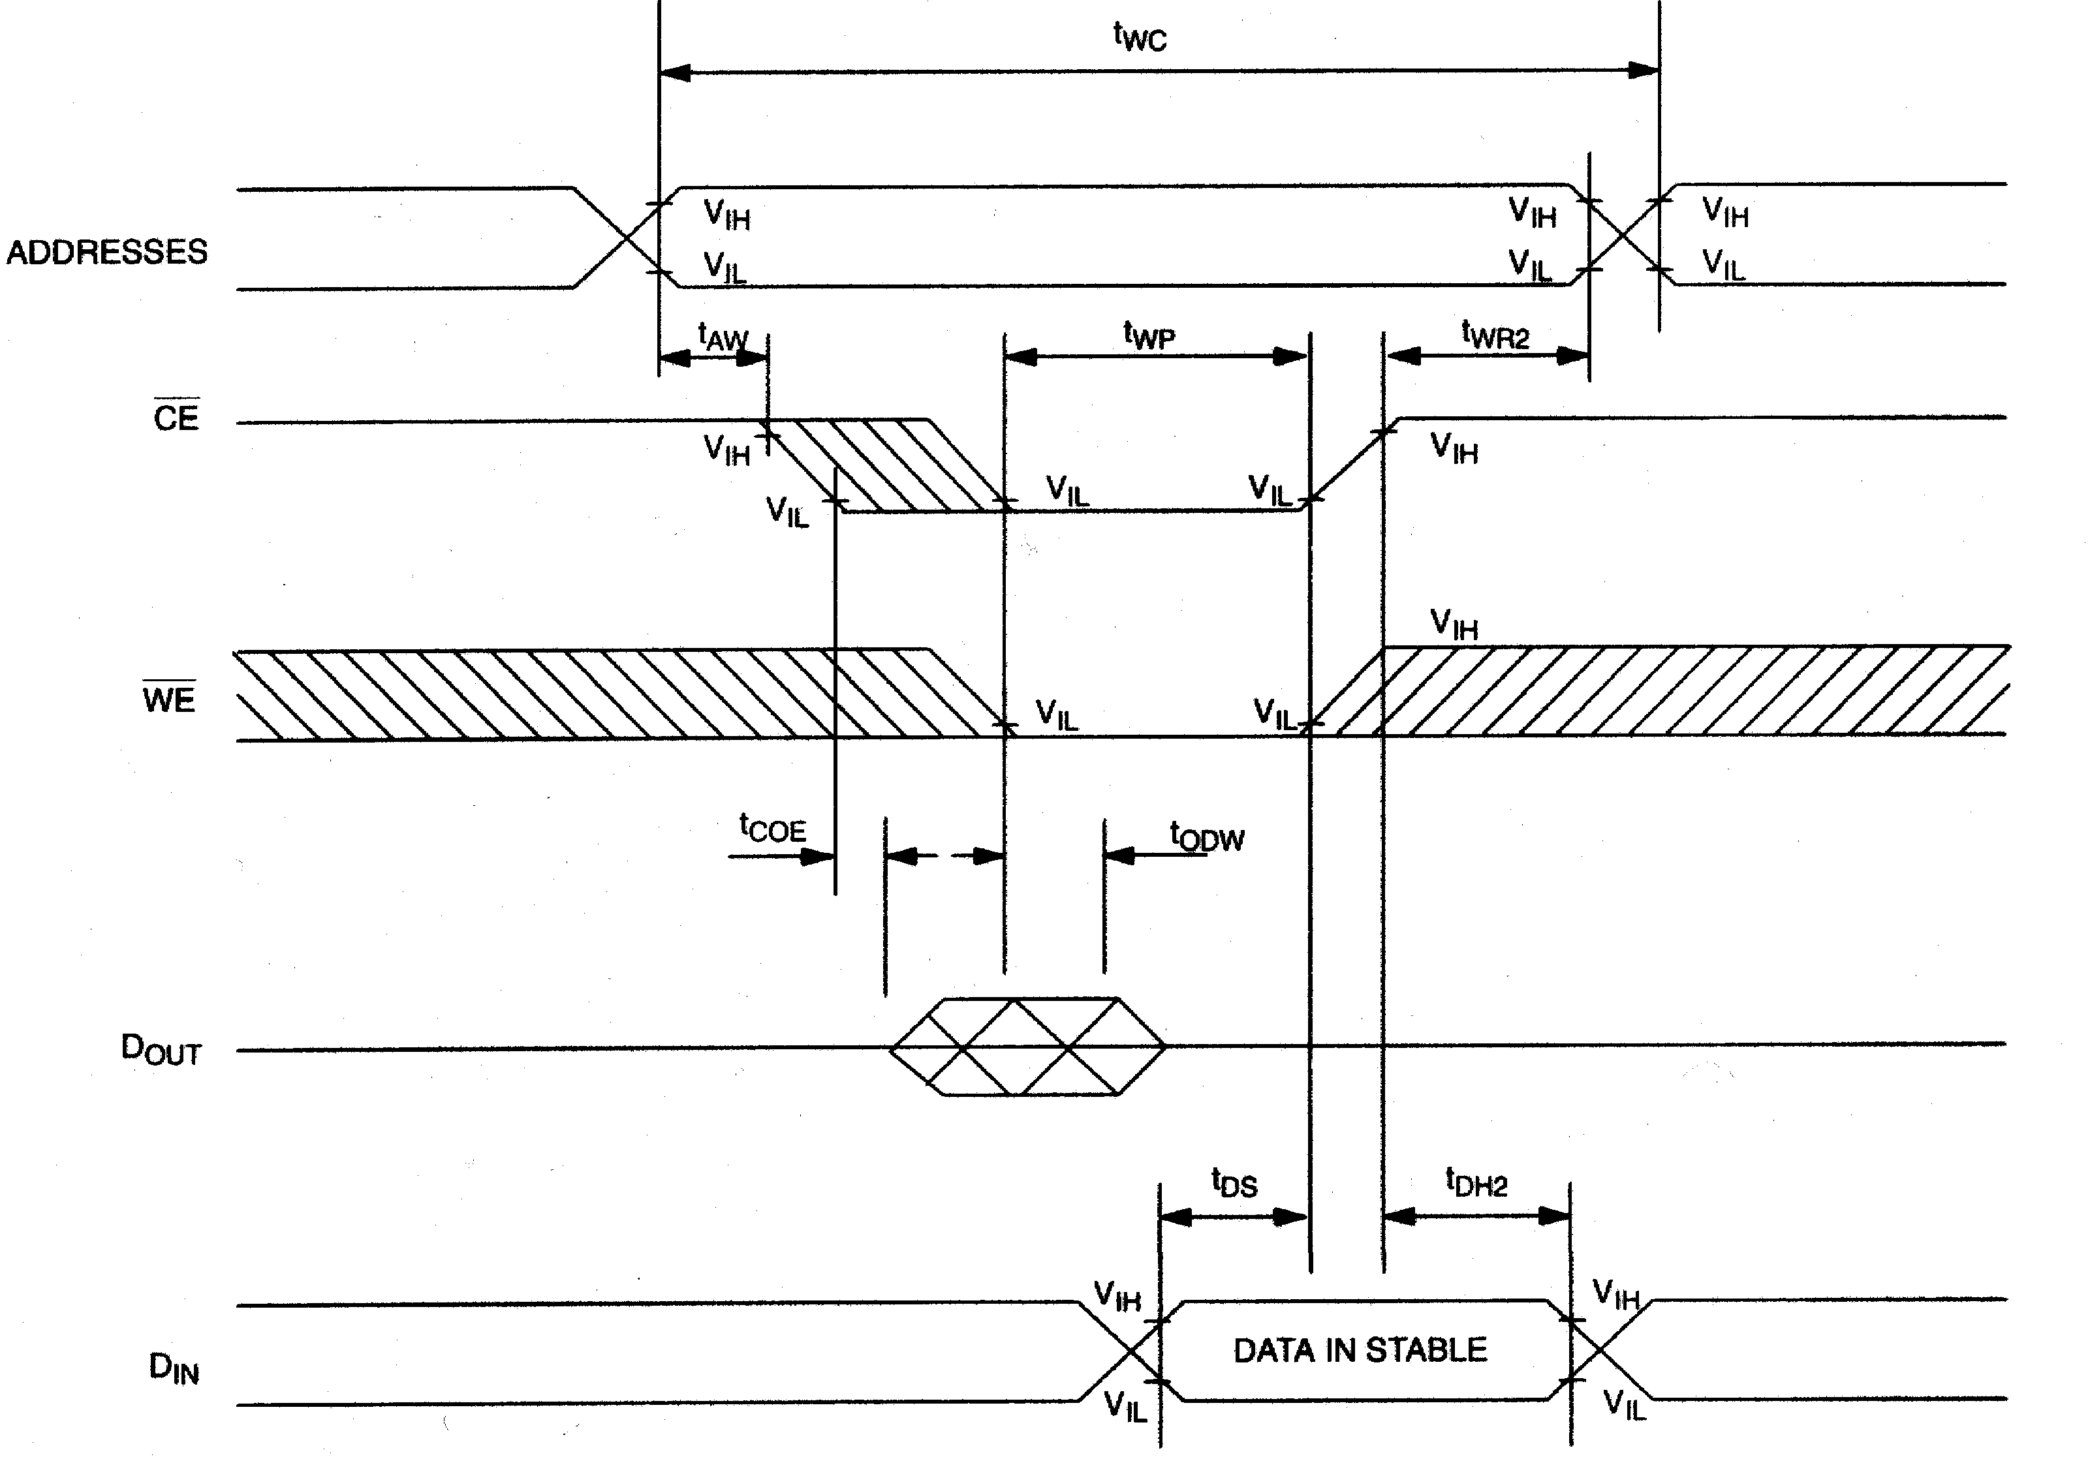
SEE NOTES 2, 3, 4, 6, 7, 8, and 13

POWER-DOWN/POWER-UP CONDITION

SEE NOTE 11

POWER-DOWN/POWER-UP TIMING (tA: See Note 10)
PARAMETER | SYMBOL | MIN | TYP | MAX | UNITS | NOTES
VCC Fail Detect to CE and WE Inactive | tPD |  |  | 1.5 | μs | 11
VCC slew from VTP to 0V | tF | 150 |  |  | μs
VCC slew from 0V to VTP | tR | 150 |  |  | μs
VCC Valid to CE and WE Inactive | tPU |  |  | 2 | ms
VCC Valid to End of Write Protection | tREC |  |  | 125 | ms

7 of 13

DS1230Y/AB

(tA=25°C)
PARAMETER | SYMBOL | MIN | TYP | MAX | UNITS | NOTES
Expected Data Retention Time | tDR | 10 |  |  | years | 9

WARNING:
Under no circumstance are negative undershoots, of any amplitude, allowed when device is in battery backup mode.

NOTES:
1. WE is high for a Read Cycle.

2. OE = VIH or VIL. If OE = VIH during write cycle, the output buffers remain in a high-impedance state.

3. tWP is specified as the logical AND of CE and WE . tWP is measured from the latter of CE or WE
going low to the earlier of CE or WE going high.

4. tDH, tDS are measured from the earlier of CE or WE going high.

5. These parameters are sampled with a 5 pF load and are not 100% tested.

6. If the CE low transition occurs simultaneously with or latter than the WE low transition, the output buffers remain in a high-impedance state during this period.

7. If the CE high transition occurs prior to or simultaneously with the WE high transition, the output buffers remain in high-impedance state during this period.

8. If WE is low or the WE low transition occurs prior to or simultaneously with the CE low transition, the output buffers remain in a high-impedance state during this period.

9. Each DS1230 has a built-in switch that disconnects the lithium source until the user first applies VCC.
The expected tDR is defined as accumulative time in the absence of VCC starting from the time power
is first applied by the user. This parameter is assured by component selection, process control, and
design. It is not measured directly during production testing.

10. All AC and DC electrical characteristics are valid over the full operating temperature range. For commercial products, this range is 0°C to 70°C. For industrial products (IND), this range is -40°C to
+85°C.

11. In a power-down condition the voltage on any pin may not exceed the voltage on VCC.

12. tWR1 and tDH1 are measured from WE going high.

13. tWR2 and tDH2 are measured from CE going high.

14. DS1230 modules are recognized by Underwriters Laboratory (U.L.®) under file E99151.

DC TEST CONDITIONS AC TEST CONDITIONS Outputs Open Output Load: 100 pF + 1TTL Gate Cycle = 200 ns for operating current Input Pulse Levels: 0 - 3.0V
All voltages are referenced to ground Timing Measurement Reference Levels
Input: 1.5V Output: 1.5V
Input pulse Rise and Fall Times: 5 ns

8 of 13

ORDERING INFORMATION
DS1230Y/AB
Part Number | Temperature Range | Supply  Tolerance | Pin/Package | Speed Grade
DS1230AB-70 | 0°C to +70°C | 5V ± 5% | 28 / 740 EMOD | 70ns
DS1230AB-70+ | 0°C to +70°C | 5V ± 5% | 28 / 740 EMOD | 70ns
DS1230ABP-70 | 0°C to +70°C | 5V ± 5% | 34 / PowerCap* | 70ns
DS1230ABP-70+ | 0°C to +70°C | 5V ± 5% | 34 / PowerCap* | 70ns
DS1230AB-70IND | -40°C to +85°C | 5V ± 5% | 28 / 740 EMOD | 70ns
DS1230AB-70IND+ | -40°C to +85°C | 5V ± 5% | 28 / 740 EMOD | 70ns
DS1230ABP-70IND | -40°C to +85°C | 5V ± 5% | 34 / PowerCap* | 70ns
DS1230ABP-70IND+ | -40°C to +85°C | 5V ± 5% | 34 / PowerCap* | 70ns
DS1230AB-85 | 0°C to +70°C | 5V ± 5% | 28 / 740 EMOD | 85ns
DS1230AB-85+ | 0°C to +70°C | 5V ± 5% | 28 / 740 EMOD | 85ns
DS1230AB-100 | 0°C to +70°C | 5V ± 5% | 28 / 740 EMOD | 100ns
DS1230AB-100+ | 0°C to +70°C | 5V ± 5% | 28 / 740 EMOD | 100ns
DS1230ABP-100 | 0°C to +70°C | 5V ± 5% | 34 / PowerCap* | 100ns
DS1230ABP-100+ | 0°C to +70°C | 5V ± 5% | 34 / PowerCap* | 100ns
DS1230AB-120 | 0°C to +70°C | 5V ± 5% | 28 / 740 EMOD | 120ns
DS1230AB-120+ | 0°C to +70°C | 5V ± 5% | 28 / 740 EMOD | 120ns
DS1230AB-120IND | -40°C to +85°C | 5V ± 5% | 28 / 740 EMOD | 120ns
DS1230AB-120IND+ | -40°C to +85°C | 5V ± 5% | 28 / 740 EMOD | 120ns
DS1230AB-150 | 0°C to +70°C | 5V ± 5% | 28 / 740 EMOD | 150ns
DS1230AB-150+ | 0°C to +70°C | 5V ± 5% | 28 / 740 EMOD | 150ns
DS1230AB-200 | 0°C to +70°C | 5V ± 5% | 28 / 740 EMOD | 200ns
DS1230AB-200+ | 0°C to +70°C | 5V ± 5% | 28 / 740 EMOD | 200ns
DS1230AB-200IND | -40°C to +85°C | 5V ± 5% | 28 / 740 EMOD | 200ns
DS1230AB-200IND+ | -40°C to +85°C | 5V ± 5% | 28 / 740 EMOD | 200ns
DS1230Y-70 | 0°C to +70°C | 5V ± 10% | 28 / 740 EMOD | 70ns
DS1230Y-70+ | 0°C to +70°C | 5V ± 10% | 28 / 740 EMOD | 70ns
DS1230YP-70 | 0°C to +70°C | 5V ± 10% | 34 / PowerCap* | 70ns
DS1230YP-70+ | 0°C to +70°C | 5V ± 10% | 34 / PowerCap* | 70ns
DS1230Y-70IND | -40°C to +85°C | 5V ± 10% | 28 / 740 EMOD | 70ns
DS1230Y-70IND+ | -40°C to +85°C | 5V ± 10% | 28 / 740 EMOD | 70ns
DS1230YP-70IND | -40°C to +85°C | 5V ± 10% | 34 / PowerCap* | 70ns
DS1230YP-70IND+ | -40°C to +85°C | 5V ± 10% | 34 / PowerCap* | 70ns
DS1230Y-85 | 0°C to +70°C | 5V ± 10% | 28 / 740 EMOD | 85ns
DS1230Y-85+ | 0°C to +70°C | 5V ± 10% | 28 / 740 EMOD | 85ns
DS1230Y-100 | 0°C to +70°C | 5V ± 10% | 28 / 740 EMOD | 100ns
DS1230Y-100+ | 0°C to +70°C | 5V ± 10% | 28 / 740 EMOD | 100ns
DS1230YP-100 | 0°C to +70°C | 5V ± 10% | 34 / PowerCap* | 100ns
DS1230YP-100+ | 0°C to +70°C | 5V ± 10% | 34 / PowerCap* | 100ns
DS1230Y-120 | 0°C to +70°C | 5V ± 10% | 28 / 740 EMOD | 120ns
DS1230Y-120+ | 0°C to +70°C | 5V ± 10% | 28 / 740 EMOD | 120ns
DS1230Y-120IND | -40°C to +85°C | 5V ± 10% | 28 / 740 EMOD | 120ns
DS1230Y-120IND+ | -40°C to +85°C | 5V ± 10% | 28 / 740 EMOD | 120ns
DS1230Y-150 | 0°C to +70°C | 5V ± 10% | 28 / 740 EMOD | 150ns
DS1230Y-150+ | 0°C to +70°C | 5V ± 10% | 28 / 740 EMOD | 150ns
DS1230Y-200 | 0°C to +70°C | 5V ± 10% | 28 / 740 EMOD | 200ns
DS1230Y-200+ | 0°C to +70°C | 5V ± 10% | 28 / 740 EMOD | 200ns
DS1230Y-200IND | -40°C to +85°C | 5V ± 10% | 28 / 740 EMOD | 200ns
DS1230Y-200IND+ | -40°C to +85°C | 5V ± 10% | 28 / 740 EMOD | 200ns
+ Denotes lead(Pb)-free/RoHS-compliant product.
* DS9034PC or DS9034PCI (PowerCap) required. Must be ordered separately.

9 of 13

PACKAGE INFORMATION
DS1230Y/AB
For the latest package outline information and land patterns, go to http://www.maxim-ic.com/packages.

PACKAGE TYPE | PACKAGE CODE | DOCUMENT NO.
28 EDIP | MDT28+3 | 21-0245
34 PWRCP | PC2+4 | 21-0246

DS1230Y/AB NONVOLATILE SRAM, 34-PIN POWERCAP MODULE

PKG DIM | INCHES
PKG DIM | MIN NOM MAX
A | 0.920 | 0.925 | 0.930
B | 0.980 | 0.985 | 0.990
C | - | - | 0.080
D | 0.052 | 0.055 | 0.058
E | 0.048 | 0.050 | 0.052
F | 0.015 | 0.020 | 0.025
G | 0.020 | 0.025 | 0.030

10 of 13

DS1230Y/AB DS1230Y/AB NONVOLATILE SRAM, 34-PIN POWERCAP MODULE WITH POWERCAP

PKG DIM | INCHES
PKG DIM | MIN NOM MAX
A | 0.920 | 0.925 | 0.930
B | 0.955 | 0.960 | 0.965
C | 0.240 | 0.245 | 0.250
D | 0.052 | 0.055 | 0.058
E | 0.048 | 0.050 | 0.052
F | 0.015 | 0.020 | 0.025
G | 0.020 | 0.025 | 0.030

ASSEMBLY AND USE
Reflow soldering
Dallas Semiconductor recommends that PowerCap Module bases experience one pass through solder reflow oriented label-side up (live-bug).

Hand soldering and touch-up
Do not touch soldering iron to leads for more than 3 seconds. To solder, apply flux to the pad, heat the lead frame pad and apply solder. To remove part, apply flux, heat pad until solder reflows, and use a solder wick.

LPM replacement in a socket
To replace a Low Profile Module in a 68-pin PLCC socket, attach a DS9034PC PowerCap to a module base then insert the complete module into the socket one row of leads at a time, pushing only on the corners of the cap. Never apply force to the center of the device. To remove from a socket, use a PLCC

11 of 13

DS1230Y/AB extraction tool and ensure that it does not hit or damage any of the module IC components. Do not use any other tool for extraction.

RECOMMENDED POWERCAP MODULE LAND PATTERN

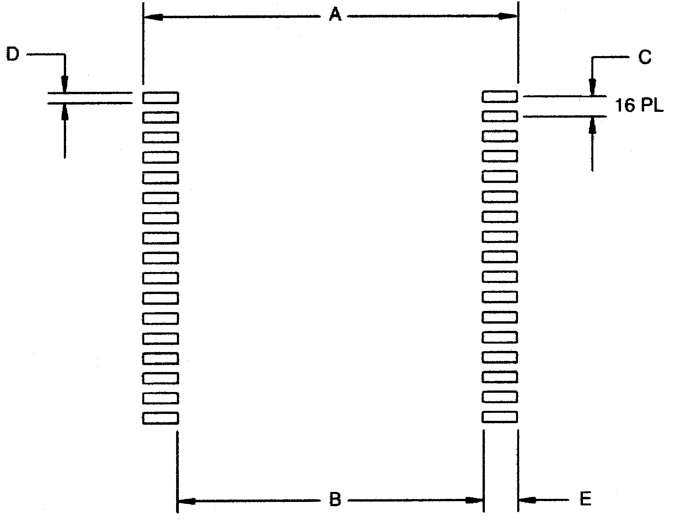
PKG DIM | INCHES
PKG DIM | MIN NOM MAX
A | - | 1.050 | -
B | - | 0.826 | -
C | - | 0.050 | -
D | - | 0.030 | -
E | - | 0.112 | -

RECOMMENDED POWERCAP MODULE SOLDER STENCIL

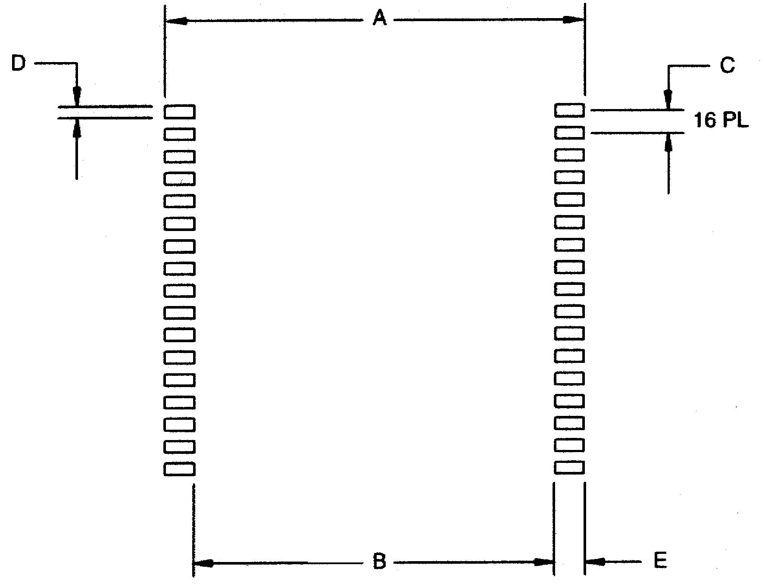
PKG DIM | INCHES
PKG DIM | MIN NOM MAX
A | - | 1.050 | -
B | - | 0.890 | -
C | - | 0.050 | -
D | - | 0.030 | -
E | - | 0.080 | -

12 of 13

REVISION HISTORY
DS1230Y/AB
REVISION DATE | DESCRIPTION | PAGES CHANGED
121907 | Added package information table.  Removed the DIP module package drawing and dimension table. | 9, 10

13 of 13

