DS275
Line-Powered RS-232 Transceiver Chip

Low-power serial transmitter/receiver for


Transmitter steals power from receive signal line to save power
Ultra-low static current, even when connected to RS-232-E port
Variable transmitter level from +5 to +12 volts
Compatible with RS-232-E signals
Available in 8-pin, 150 mil wide SOIC
package (DS275S)
Low-power CMOS

ORDERING INFORMATION DS275 8-pin DIP DS275S 8-pin SOIC DS275E 14-pin TSSOP

RXOUT | 1 | 8 | VCC
VDRV | 2 | 7 | RXIN
TXIN | 3 | 6 | NC
GND | 4 | 5 | TXOUT

DS275 8-Pin DIP (300-mil) DS275 8-Pin SOIC (150-mil)

DRV
RXOUT | 1 | 14 | VCC
NC | 2 | 13 | NC
V | 3 | 12 | NC
NC | 4 | 11 | RXIN
TXIN | 5 | 10 | NC
NC | 6 | 9 | NC
GND | 7 | 8 | TXOUT

DS275E 14-Pin TSSOP

PIN DESCRIPTION
RXOUT - RS-232 Receiver Output
VDRV - Transmit driver +V
TXIN - RS-232 Driver Input
GND - System Ground (0V)
TXOUT - RS-232 Driver Output
NC - No Connection
RXIN - RS-232 Receive Input
VCC -System Logic Supply (+5V)

DESCRIPTION
The DS275 Line-Powered RS-232 Transceiver Chip is a CMOS device that provides a low-cost, very
low-power interface to RS-232 serial ports. The receiver input translates RS-232 signal levels to common
CMOS/TTL levels. The transmitter employs a unique circuit which steals current from the receive RS-
232 signal when that signal is in a negative state (marking). Since most serial communication ports remain in a negative state statically, using the receive signal for negative power greatly reduces the DS275’s static power consumption. This feature is especially important for battery-powered systems such as laptop computers, remote sensors, and portable medical instruments. During an actual communication session, the DS275’s transmitter will use system power (5-12 volts) for positive transitions while still employing the receive signal for negative transitions.

1 of 8 112299

DS275 BLOCK DIAGRAM Figure 1

OPERATION
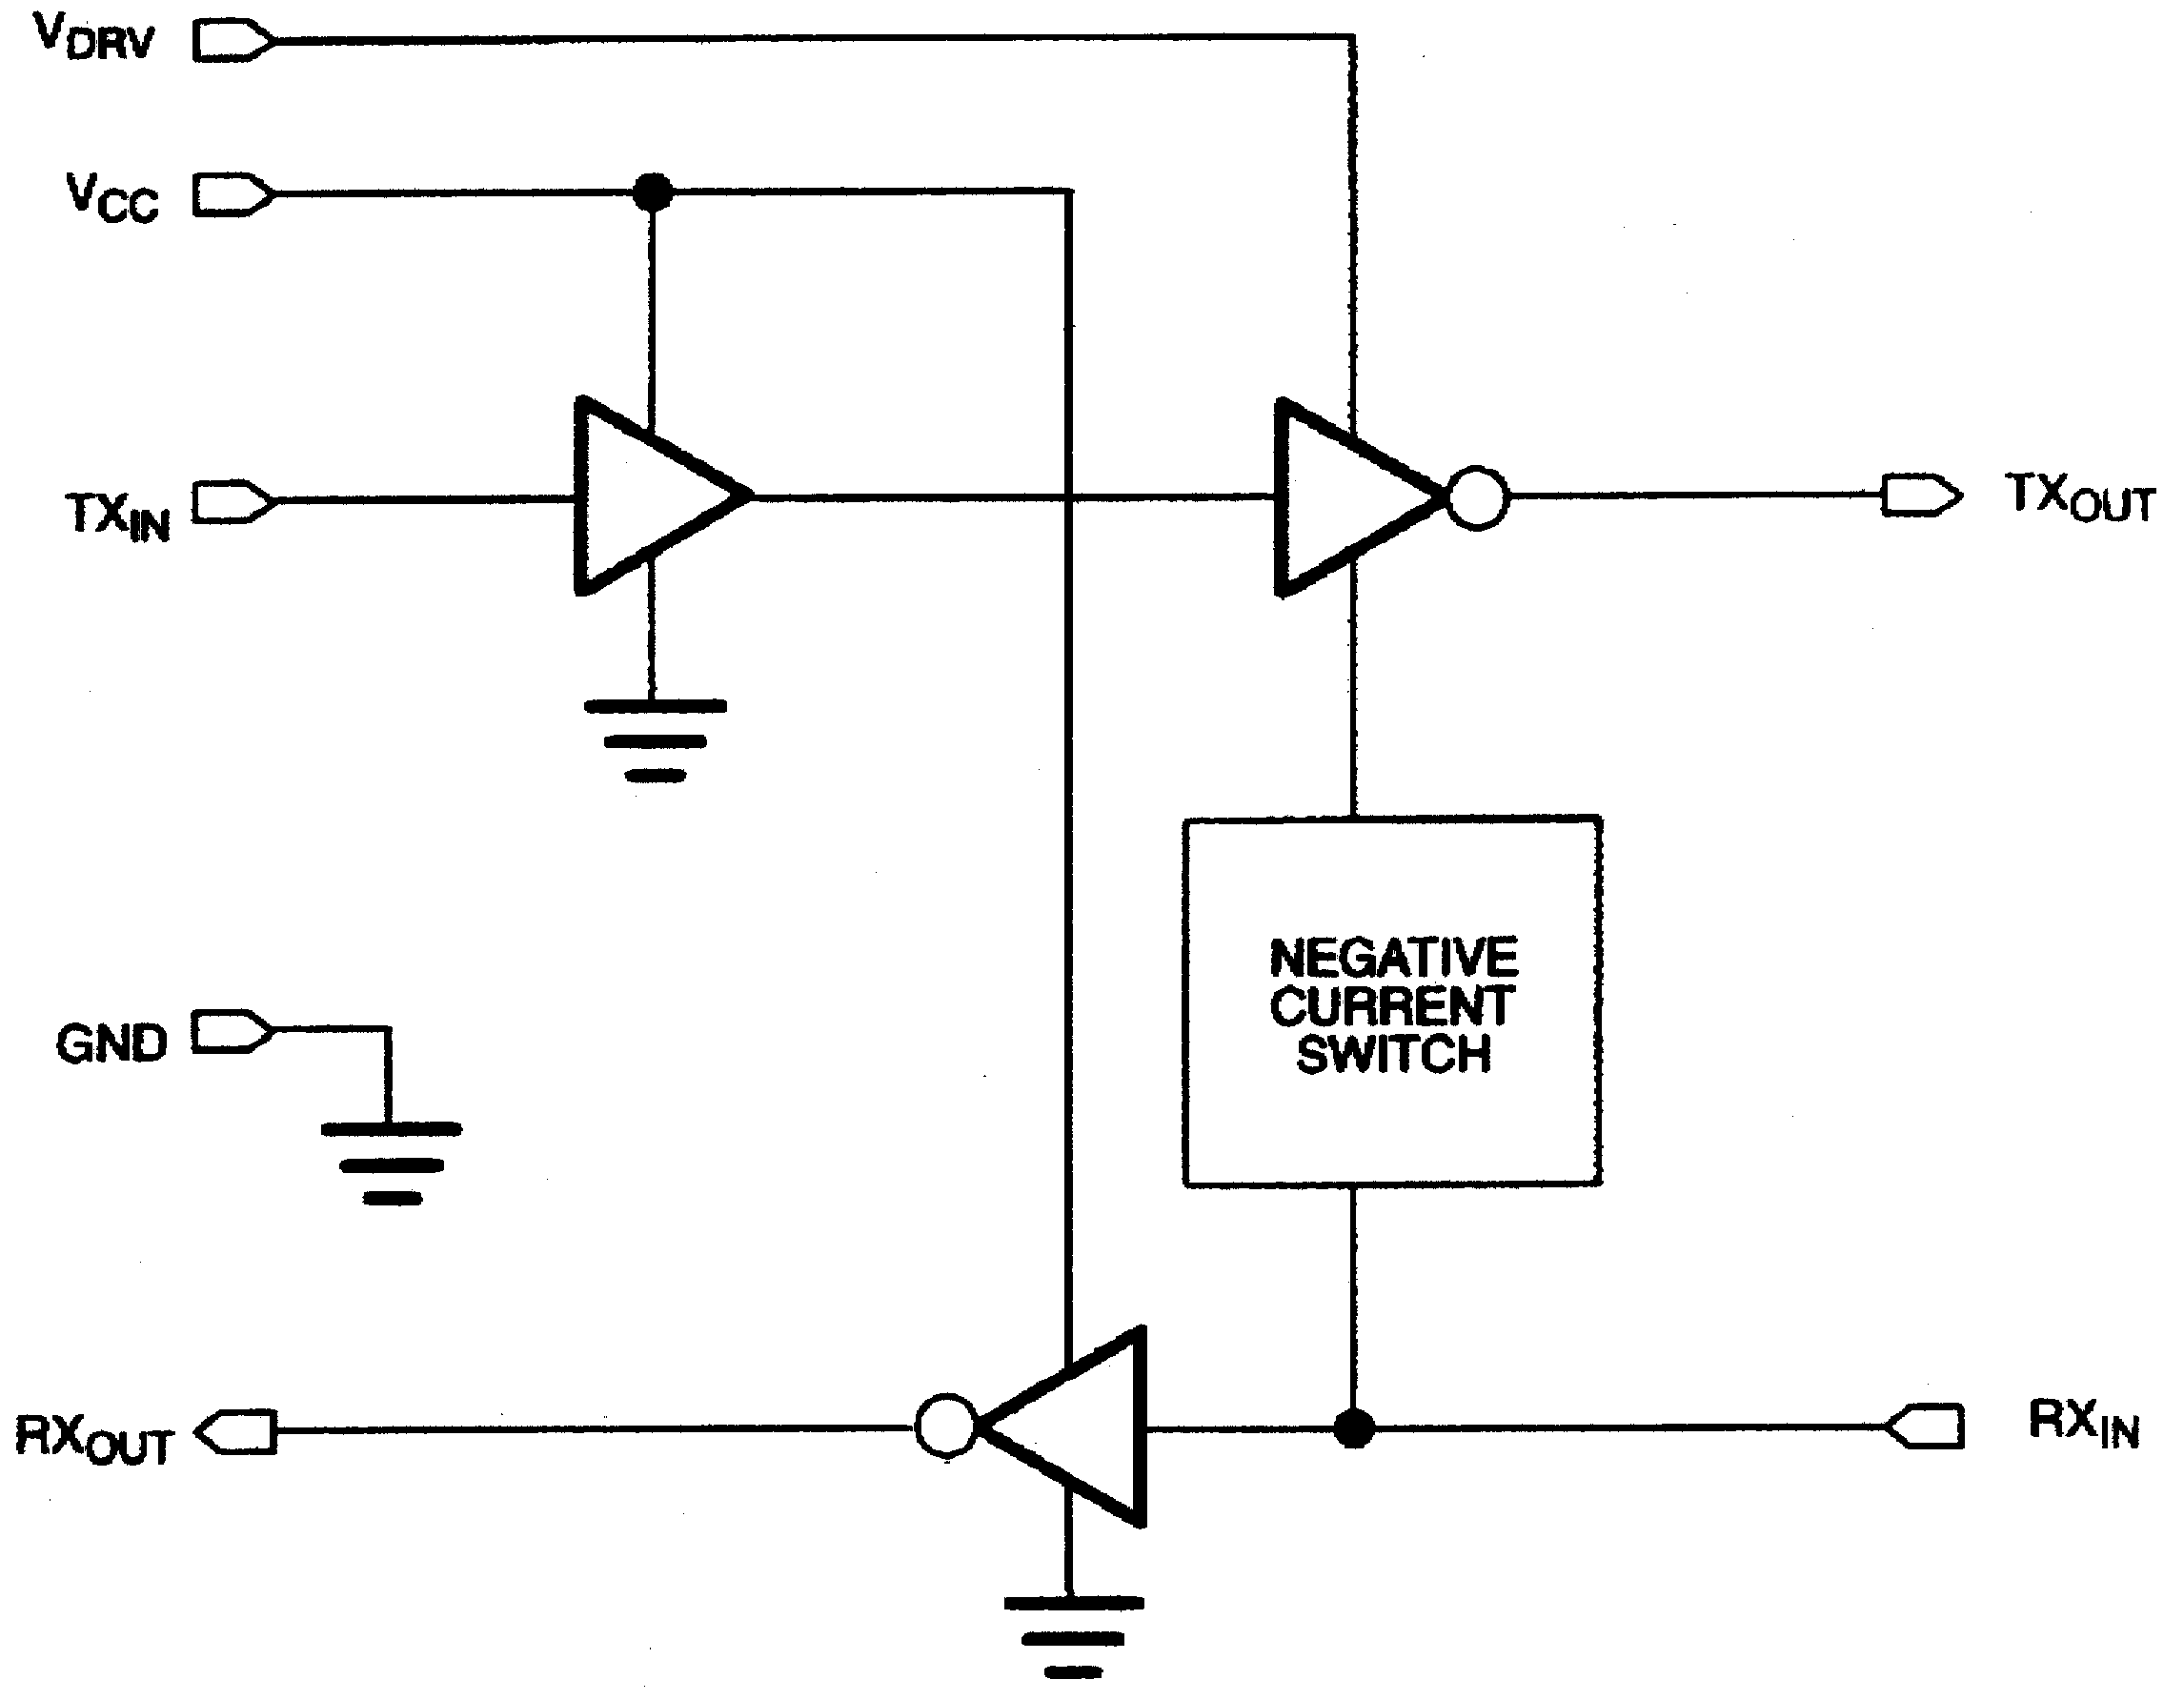

Designed for the unique requirements of battery-backed systems, the DS275 provides a low-power half-
duplex interface to an RS-232 serial port. Typically, a designer must use an RS-232 device which uses system power during both negative and positive transitions of the transmit signal to the RS-232 port. If the connector to the RS-232 port is left connected for an appreciable time after the communication session has ended, power will statically flow into that port, draining the battery capacity. The DS275 eliminates this static current drain by stealing current from the receive line (RXIN) of the RS-232 port when that line is at a negative level (marking). Since most asynchronous communication over an RS-232 connection typically remains in a marking state when data is not being sent, the DS275 will not consume system power in this condition. System power would only be used when positive-going transitions are needed on the transmit RS-232 output (TXOUT) when data is sent. However, since synchronous communication sessions typically exhibit a very low duty-cycle, overall system power consumption remains low.

RECEIVER SECTION
The RXIN pin is the receive input for an RS-232 signal whose levels can range from ±3 to ±15 volts. A
negative data signal is called a mark while a positive data signal is called a space. These signals are inverted and then level-shifted to normal +5-volt CMOS/TTL logic levels. The logic output associated with RXIN is RXOUT which swings from +VCC to ground. Therefore, a mark on RXIN produces a logic 1 at RXOUT; a space produces a logic 0.

The input threshold of RXIN is typically around 1.8 volts with 500 millivolts of hysteresis to improve noise rejection. Therefore, an input positive-going signal must exceed 1.8 volts to cause RXOUT to switch states. A negative-going signal must now be lower than 1.3 volts (typically) to cause RXOUT to switch again. An open on RXIN is interpreted as a mark, producing a logic 1 at RXOUT.

TRANSMITTER SECTION
TXIN is the CMOS/TTL-compatible input for digital data from the user system. A logic 1 at TXIN
produces a mark (negative data signal) at TXOUT while a logic 0 produces a space (positive data signal). As mentioned earlier, the transmitter section employs a unique driver design that uses the RXIN line for swinging to negative levels. The RXIN line must be in a marking or idle state to take advantage of this design; if RXIN is in a spacing state, TXOUT will only swing to ground. When TXOUT needs to transition to a positive level, it uses the VDRV power pin for this level. VDRV can be a voltage supply between 5 to 12
volts, and in many situations it can be tied directly to the +5 volt VCC supply. It is important to note that
VDRV must be greater than or equal to VCC at all times.

The voltage range on VDRV permits the use of a 9-volt battery in order to provide a higher voltage level when TXOUT is in a space state. When VCC is shut off to the DS275 and VDRV is still powered (as might happen in a battery-backed condition), only a small leakage current (about 50-100 nA) will be drawn. If TXOUT is loaded during such a condition, VDRV will draw current only if RXIN is not in a negative state. During normal operation (VCC=5 volts), VDRV will draw less than 2 uA when TXOUT is marking. Of course, when TXOUT is spacing, VDRV will draw substantially more current⎯ about 3 mA, depending upon its voltage and the impedance that TXOUT sees.

The TXOUT output is slew rate-limited to less than 30 volts/us in accordance with RS-232 specifications. In the event TXOUT should be inadvertently shorted to ground, internal current-limiting circuitry prevents damage, even if continuously shorted.

RS-232 COMPATIBILITY
The intent of the DS275 is not so much to meet all the requirements of the RS-232 specification as to
offer a low-power solution that will work with most RS-232 ports with a connector length of less than 10 feet. As a prime example, the DS275 will not meet the RS-232 requirement that the signal levels be at least ±5 volts minimum when terminated by a 3 kΩ load and VDRV = +5 volts. Typically a voltage of 4 volts will be present at TXOUT when spacing. However, since most RS-232 receivers will correctly interpret any voltage over 2 volts as a space, there will be no problem transmitting data.

APPLICATIONS INFORMATION
The DS275 is designed as a low-cost, RS-232-E interface expressly tailored for the unique requirements
of battery-operated handheld products. As shown in the electrical specifications, the DS275 draws exceptionally low operating and static current. During normal operation when data from the handheld system is sent from the TXOUT output, the DS275 only draws significant VDRV current when TXOUT transitions positively (spacing). This current flows primarily into the RS-232 receiver’s 3-7 kΩ load at the other end of the attaching cable. When TXOUT is marking (a negative data signal), the VDRV current falls dramatically since the negative voltage is provided by the transmit signal from the other end of the cable. This represents a large reduction in overall operating current, since typical RS-232 interface chips use charge-pump circuits to establish both positive and negative levels at the transmit driver output.

To obtain the lowest power consumption from the DS275, observe the following guidelines. First, to minimize VDRV current when connected to an RS-232 port, always maintain TXIN at a logic 1 when data is not being transmitted (idle state). This will force TXOUT into the marking state, minimizing VDRV current. Second, VDRV current will drop to less than 100 nA when VCC is grounded. Therefore, if VDRV is tied directly to the system battery, the logic +5 volts can be turned off to achieve the lowest possible power state.

FULL-DUPLEX OPERATION
The DS275 is intended primarily for half-duplex operation; that is, RXIN should remain idle in the
marking state when transmitting data out TXOUT and visa versa. However, the part can be operated full- duplex with most RS-232-E serial ports since signals swinging between 0 and +5V will usually be correctly interpreted by an RS-232-E receiver device. The 5-volt swing occurs when TXOUT attempts to swing negative while RXIN is at a positive voltage, which turns on an internal weak pulldown to ground for the TXOUT driver’s negative reference. So, transmit mark signals at TXOUT may have voltage jumps from some negative value (corresponding to RXIN marking) to approximately ground. One possible
problem that may occur in this case is if the receiver at the other end requires a negative voltage for recognizing a mark. In this situation, the full-duplex circuit shown in Figure 3 can be used as analternative. The 22 μF capacitor forms a negative-charge reservoir; consequently, when the TXD line is spacing (positive), TXOUT still has a negative source available for a time period determined by the capacitor and the load resistance at the other end (3-7 kΩ). This circuit was tested from 150-19,200 bps with error-free operation using a SN75154 Quad Line Receiver as the receiver for the TXOUT signal. Note that the SN75154 can have a marking input threshold below ground; hence there is the need for TXOUT to swing both positive and negative in full-duplex operation with this device.

HANDHELD RS-232-C APPLICATION USING A STEREO MINI-JACK Figure 2

FULL-DUPLEX CIRCUIT USING NEGATIVE-CHARGE STORAGE Figure 3
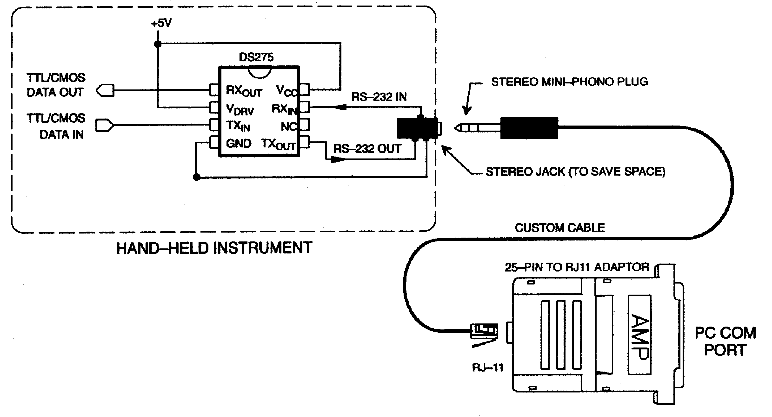

NOTE:
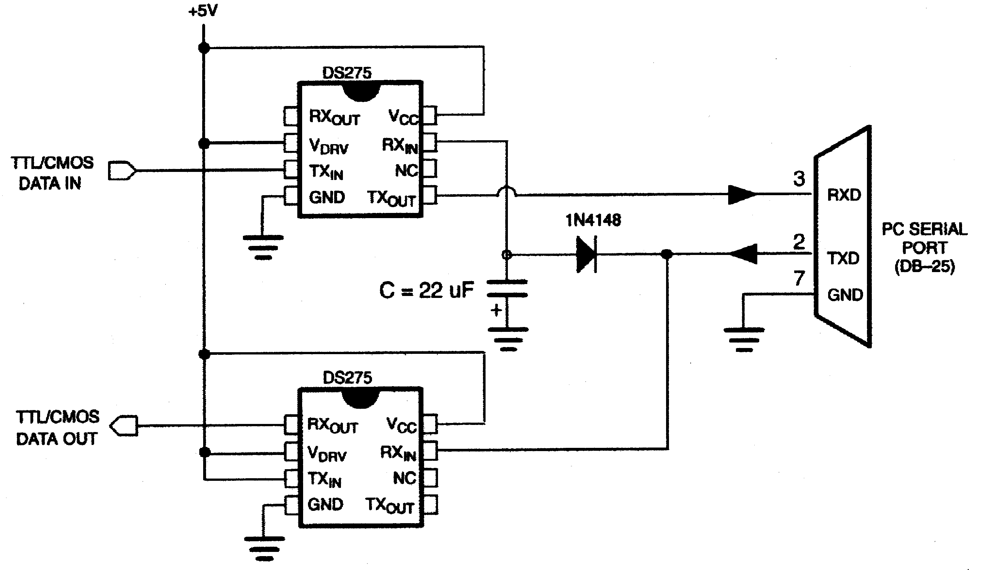

The capacitor stores negative charge whenever the TXD signal from the PC serial port is in a marking
data state (a negative voltage that is typically -10 volts). The top DS275’s TXOUT uses this negative charge reservoir when it is in a marking state. The capacitor will discharge to 0 volts when the TXD line is spacing (and TXOUT is still marking) at a time constant determined by its value and the value of the load resistance reflected back to TXOUT. However, when TXD is marking the capacitor will quickly charge back to -10 volts. Note that TXD remains in a marking state when idle, which improves the performance of this circuit.
ABSOLUTE MAXIMUM RATINGS*
VCC -0.3 to +7.0 volts
VDRV -0.3 to +13.0 volts
RXIN ±15 volts
TXIN -0.3 to VCC + 0.3 volts
TXOUT ±15 volts
RXOUT -0.3 to VCC + 0.3 volts Storage Temperature -55°C to +125°C Operating Temperature 0°C to 70°C

* This is a stress rating only and functional operation of the device at these or any other conditions above those indicated in the operation sections of this specification is not implied. Exposure to absolute maximum rating conditions for extended periods of time may affect reliability.

RECOMMENDED DC OPERATING CONDITIONS
PARAMETER | SYMBOL | MIN | TYP | MAX | UNITS | NOTES
Logic Supply | VCC | 4.5 | 5.0 | 5.5 | V | 1
Transmit Driver Supply | VDRV | 4.5 | 5-12 | 13.0 | V | 1
Logic 1 Input | VIH | 2.0 |  | VCC+0.3 | V | 2
Logic 0 Input | VIL | -0.3 |  | +0.8 | V
RS-232 Input Range (RXIN) | VRS | -15 |  | +15 | V
Dynamic Supply Current  TXIN = VCC  TXIN = GND | IDRV1  ICC1  IDRV1  ICC1 |  | 400  40  3.8  40 | 800  100  5.0  100 | ∝A  ∝A  ∝A  ∝A | 3
Static Supply Current  TXIN = VCC  TXIN = GND | IDRV2  ICC2  IDRV2  ICC2 |  | 1.5  10.0  3.8  10.0 | 10.0  15.0  5.0  20.0 | ∝A  ∝A  mA  ∝A | 4
Driver Leakage  Current (VCC=0V) | IDRV3 |  | 0.05 | 1.0 | ∝A | 5

DC ELECTRICAL CHARACTERISTICS (0°C to 70°C; VCC = VDRV = 5V ± 10%)

PARAMETER | SYMBOL | MIN | TYP | MAX | UNITS | NOTES
TXOUT Level High | VOTXH | 3.5 | 4.0 | 5.0 | V | 6
TXOUT Level Low | VOTXL | -8.5 | -9.0 |  | V | 7
TXOUT Short Circuit Current | ISC |  | +60 | +85 | mA
TXOUT Output Slew Rate | tSR |  |  | 30 | V/∝s
Propagation Delay | tPD |  | 5 |  | ∝s | 8
RXIN Input Threshold Low | VTL | 0.8 | 1.2 | 1.6 | V
RXIN Input Threshold High | VTH | 1.6 | 2.0 | 2.4 | V
RXIN Threshold Hysteresis | VHYS | 0.5 | 0.8 |  | V | 9
RXOUT Output Current @ 2.4V | IOH | -1.0 |  |  | mA
RXOUT Output Current @ 0.4V | IOL |  |  | 3.2 | mA

NOTES:
1. VDRV must be greater than or equal to VCC.
2. VCC = VDRV = 5V ± 10%.
3. See test circuit in Figure 4.
4. See test circuit in Figure 5.
5. See test circuit in Figure 6.
6. TXIN = VIL and TX OUT loaded by 3 kΩ to ground.
7. TXIN = VIH, RXIN = -10 volts and TXOUT loaded by 3 kΩ to ground.
8. TXIN to TXOUT - see Figure 7.
9. VHYS = VTH - VTL.
DYNAMIC OPERATING CURRENT TEST CIRCUIT Figure 4
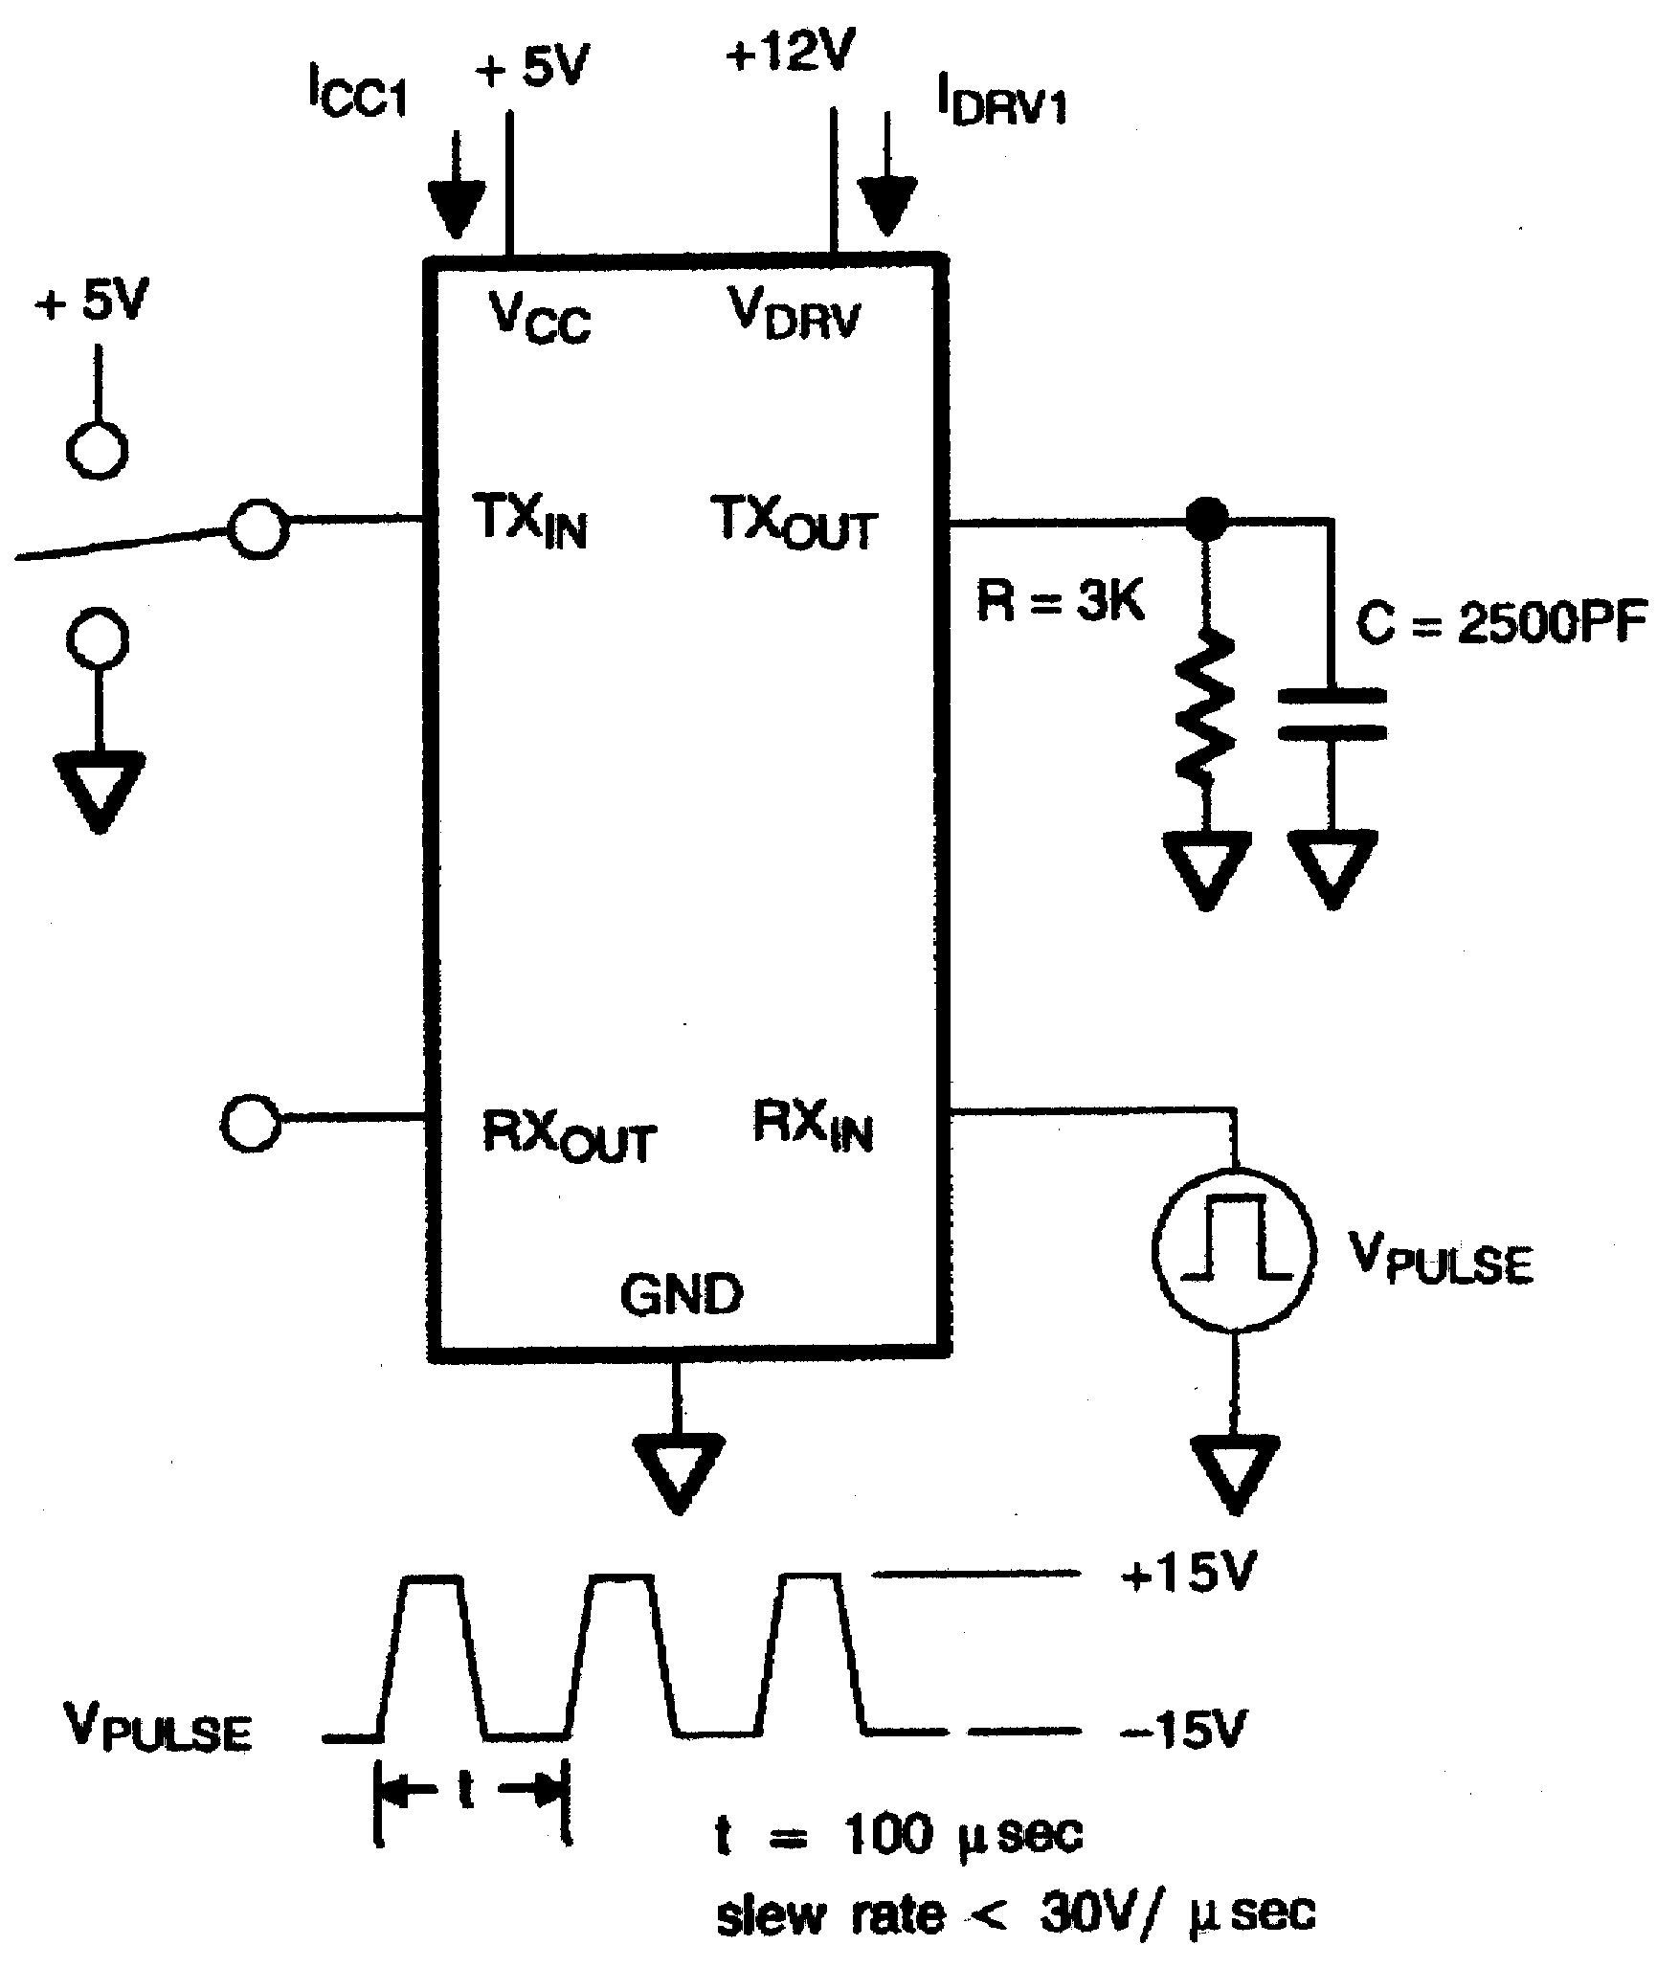

STATIC OPERATING CURRENT TEST CIRCUIT Figure 5
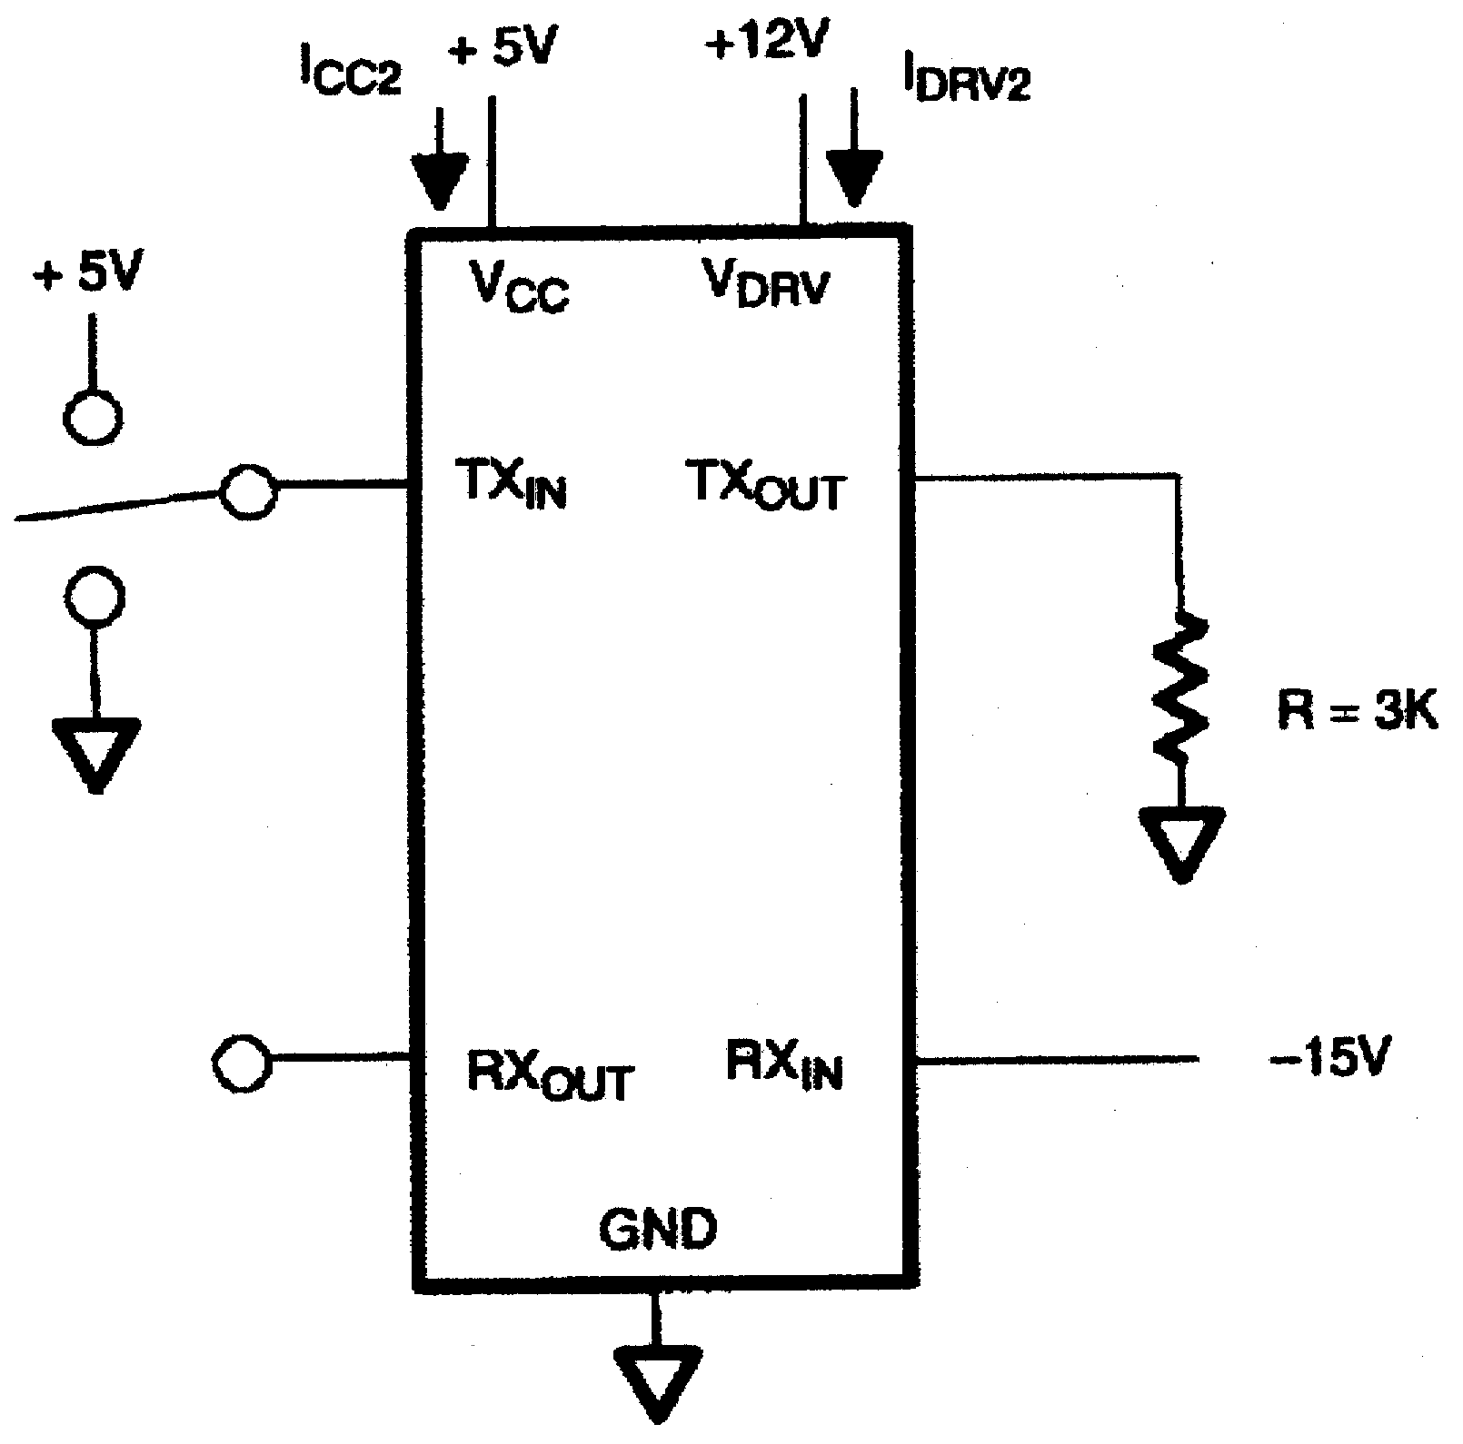

DRIVER LEAKAGE TEST CIRCUIT
Figure 6
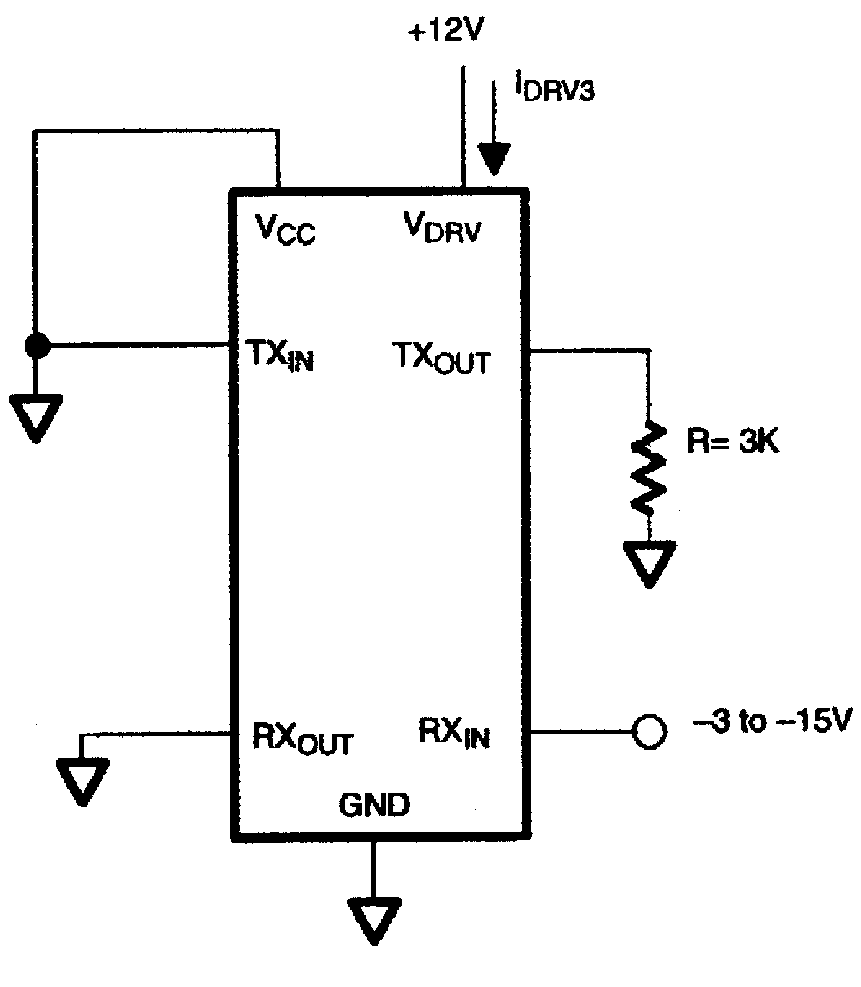

PROPAGATION DELAY TEST CIRCUIT Figure 7
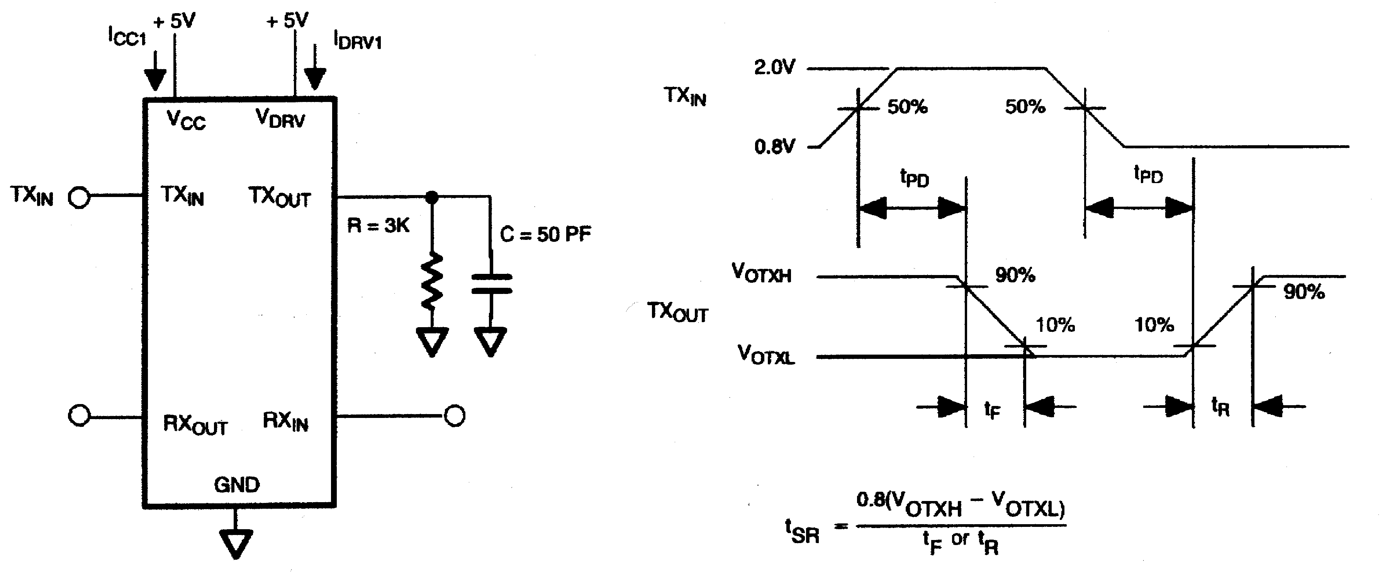

DS275E 14-PIN TSSOP
DIM | 14-PIN
DIM | MIN | MAX
A MM | - | 1.10
A1 MM | 0.05 | -
A2 MM | 0.75 | 1.05
B MM | 0.18 | 0.30
C MM | 0.09 | 0.18
D MM | 4.90 | 5.10
E MM | 4.40 NOM
e1 MM | 0.65 BSC
G MM | 0.25 REF
H MM | 6.25 | 6.55
L MM | 0.50 | 0.70
phi | 0° | 8°

