DS276
Low Power Transceiver Chip

FEATURES


PIN ASSIGNMENT

IN DRV-
battery-backed systems  Single 3V or 5V operation |  | RXOUT | 1 | 8 | VCC
 |  | VDRV+ | 2 | 7 | RXIN
 |  | TX | 3 | 6 | V
 | Ultra-low static current | GND | 4 | 5 | TXOUT
 | Compatible with RS-232-E signals

DS276 8-Pin DIP (300-mil) DS 276S 8-Pin SOIC (150-mil)

PIN DESCRIPTION
RXOUT RS-232 Receiver Output
VDRV+ Transmit Driver Positive Supply
TXIN RS-232 Driver Input
GND System Ground (0V)
TXOUT RS-232 Driver Output
VDRV- Transmit Driver Negative Supply
RXIN RS-232 Receiver Input
VCC System Logic Supply (3-5V)

ORDERING INFORMATION
DS276 8-Pin DIP
DS276S 8-Pin SOIC

DESCRIPTION
The DS276 Line-Powered RS-232 Transceiver Chip is a CMOS device that provides a low-cost, very
low-power interface to RS-232 serial ports. The receiver input translates RS-232 signal levels to common CMOS/TTL levels. The transmitter can be used with independently supplied positive and negative supplies, but in most cases will be used with the positive supply, sharing the logic supply and the negative supply stolen from the receive RS-232 signal when that signal is in a negative state (marking). By using an external reservoir capacitor and Schottky diode (see Figure 4) this negative supply can be maintained even during full-duplex operation. Since most serial communication ports remain in a negative state statically, using the receive signal for negative power greatly reduces the DS276’s static power consumption. This feature is especially important for battery-powered systems such as laptop computers, remote sensors, and portable medical instruments. During an actual communication session, the DS276’s transmitter will use system power (3-12 volts) for positive transitions while still employing the receive signal for negative transitions.

1 of 11 112299

OPERATION
Designed for the unique requirements of battery-backed systems, the DS276 provides a low-power full-or
half-duplex interface to an RS-232 serial port. Typically, a designer must use an RS-232 device which uses system power during both negative and positive transitions of the transmit signal to the RS-232 port. If the connector to the RS-232 port is left connected for an appreciable time after the communication session has ended, power will statically flow into that port, draining the battery capacity. The DS276 eliminates this static current drain by stealing current from the receive line (RXIN) of the RS-232 port when that line is at a negative level (marking). Since most asynchronous communication over an RS-232 connection typically remains in a marking state when data is not being sent, the DS276 will not consume system power in this condition. Sys-tem power would only be used when positive-going transitions are needed on the transmit RS-232 output (TXOUT) when data is sent. However, since synchronous communication sessions typically exhibit a very low duty-cycle, overall system power consumption remains low.

RECEIVER SECTION
The RXIN pin is the receive input for an RS-232 signal whose levels can range from ±3 to ±15 volts. A negative data signal is called a mark while a positive data signal is called a space. These signals are inverted and then level-shifted to normal +3 or +5 volt CMOS/TTL logic levels. The logic output associated with RXIN is RXOUT which swings from VCC to ground. Therefore, a mark on RXIN produces a logic 1 at RXOUT; a space produces a logic 0.

The input threshold of RXIN is typically around 1.8 volts with 500 millivolts of hysteresis to improve noise rejection. Therefore, an input positive-going signal must exceed 1.8 volts to cause RXOUT to switch states. A negative-going signal must now be lower than 1.3 volts (typically) to cause RXOUT to switch again. An open on RXIN is interpreted as a mark, producing a logic 1 at RXOUT.

TRANSMITTER SECTION
TXIN is the CMOS/TTL-compatible input for data from the user system. A logic 1 at TXIN produces a mark (negative data signal) at TXOUT while a logic 0 produces a space (positive data signal). As mentioned earlier, the transmitter section employs a unique driver design that can use the RXIN line for swinging to negative levels. RXIN can be connected via external circuitry to VDRV- to allow stored charge to supply this voltage during marking (or idle) states. When TXOUT needs to transition to a positive level, it uses the VDRV+ power pin for this level. VDRV+ can be a voltage supply between 3 to 12 volts, and in many situations it can be tied directly to the VCC supply. It is important to note that VDRV+ must be greater than or equal to VCC at all times.

The voltage range on VDRV+ permits the use of a 9V battery in order to provide a higher voltage level when TXOUT is in a space state. When VCC is shut off to the DS276 and VDRV+ is still powered (as might happen in a battery-backed condition), only a small leakage current (about 50-100 nA) will be drawn. If TXOUT is loaded during such a condition, VDRV+ will draw current only if RXIN is not in a negative state. During normal operation (VCC = 3 or 5 volts), VDRV+ will draw less than 2 uA when TXOUT is marking. Of course, when TXOUT is spacing, VDRV+ will draw substantially more current⎯about 3 mA, depending upon its voltage and the impedance that TXOUT sees. The TXOUT output is slew rate-limited to less than 30 volts/us in accordance with RS-232 specifications. In the event TXOUT should be inadvertently shorted to ground, internal current-limiting circuitry prevents damage, even if continuously shorted.

RS-232 COMPATIBILITY
The intent of the DS276 is not so much to meet all the requirements of the RS-232 specification as to
offer a low-power solution that will work with most RS-232 ports with a connector length of less than 10
feet. As a prime example, the DS276 will not meet the RS-232 requirement that the signal levels be at least ±5 volts minimum when terminated by a 3 kΩ load and VDRV+ = +3-5 volts. Typically 2.5 to 4 volts will be present at TXOUT when spacing under this condition, depending on the supply voltage. However, since most RS-232 receivers will correctly interpret any voltage over 2 volts as a space, there will be no problem transmitting data.

DS276 BLOCK DIAGRAM Figure 1
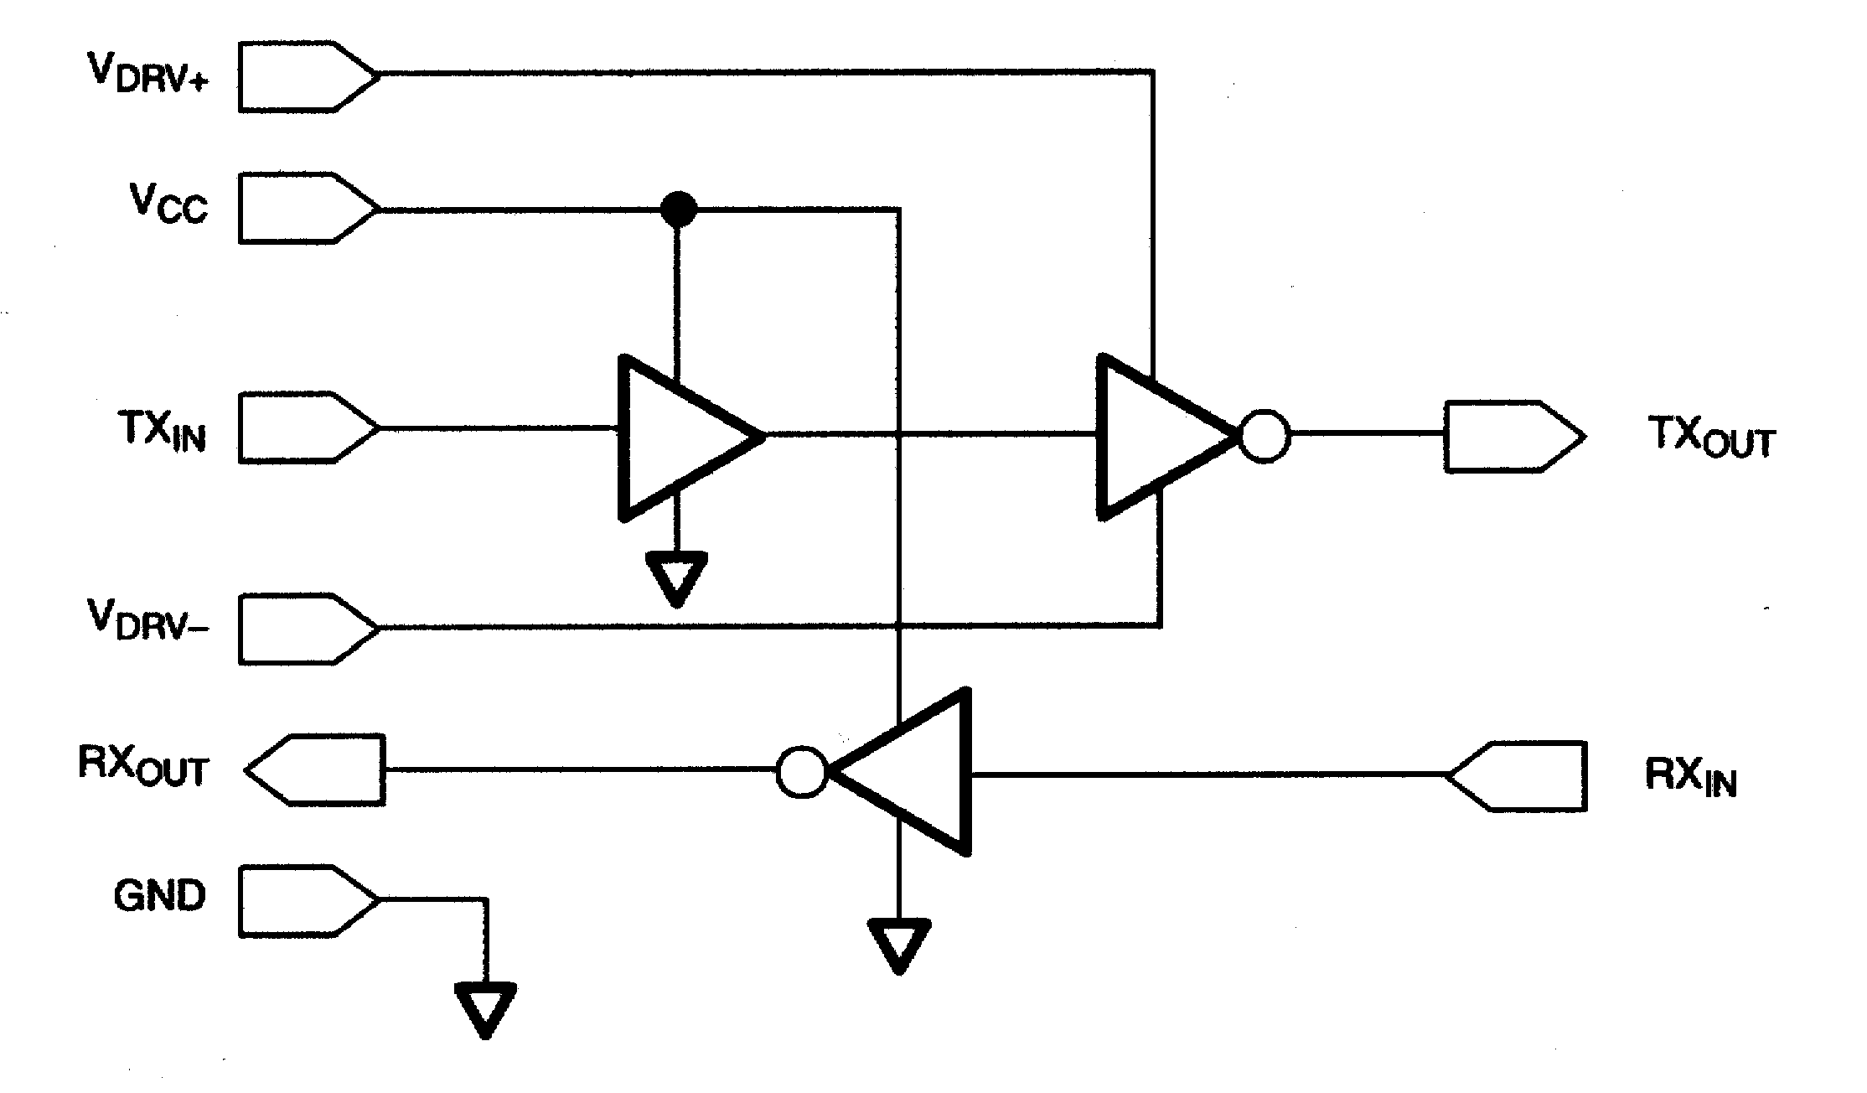

APPLICATIONS INFORMATION
The DS276 is designed as a low-cost, RS-232-E interface expressly tailored for the unique requirements
of battery-operated handheld products. As shown in the electrical specifications, the DS276 draws exceptionally low operating and static current. During normal operation when data from the handheld system is sent from the TXOUT output, the DS276 only draws significant VDRV+ current when TXOUT transitions positively (spacing). This current flows primarily into the RS-232 receiver’s 3-7 kΩ load at the other end of the attaching cable. When TXOUT is marking (a negative data signal), the VDRV+ current falls dramatically since the negative voltage is provided by the transmit signal from the other end of the cable. This represents a large reduction in overall operating current, since typical RS-232 interface chips use charge-pump circuits to establish both positive and negative levels at the transmit driver output. To obtain the lowest power consumption from the DS276, observe the following guidelines: First, to minimize VDRV+ current when connected to an RS-232 port, always maintain TXIN at a logic 1 when data is not being transmitted (idle state). This will force TXOUT into the marking state, minimizing VDRV+ current. Second, VDRV+ current will drop significantly when VCC is grounded. Therefore, if VDRV+ is derived independently from VCC (for example connected to a 9V battery), the logic supply voltage can be turned off to achieve the lowest possible power state.

FULL-DUPLEX OPERATION
The DS276 is intended for full-duplex operation using the full-duplex circuit shown in Figure 4 to
generate a negative rail from RXIN. The 22 μF capacitor forms a negative-charge reservoir; consequently, when the TXD line RXIN is spacing (positive), TXOUT still has a negative source available for a time period determined by the capacitor and the load resistance at the other end (3-7 kΩ).

SUPPLY VOLTAGE OPTIONS
The DS276 is intended primarily for use in single supply 3- or 5- volts systems. However, several supply
configurations are possible.

3V OPERATION
The simplest configuration is to use a single 3V supply for VCC and Vdrv+, and connect Vdrv- to ground. This will result in the lowest power consumption and will give adequate serial communication between
two similar devices over short distances, and into larger loads than the 3 kΩ RS-232 standard (Figure 2). If Vdrv+ is increased to 5V, and Vdrv- decreased (to less than -2V) communication with standard RS-232 devices is possible, although of course the output voltage swing of the DS276 remains below the RS-232 specification. The Vdrv- supply can be derived using the “stealing” technique shown in Figure 4.

5V OPERATION
The use of a single 5V supply for VCC and Vdrv+, and Vdrv- derived using the circuit in Figure 4 can produce reliable communication with standard RS-232 devices, although the DS276 output voltage swings are below the RS-232 minimum (Figure 3).

Increasing the magnitude of the voltage to Vdrv+ to 10 volts or more will result in “true” RS-232 output voltage levels.

SINGLE 3V OPERATION Figure 2
(See Note 3)
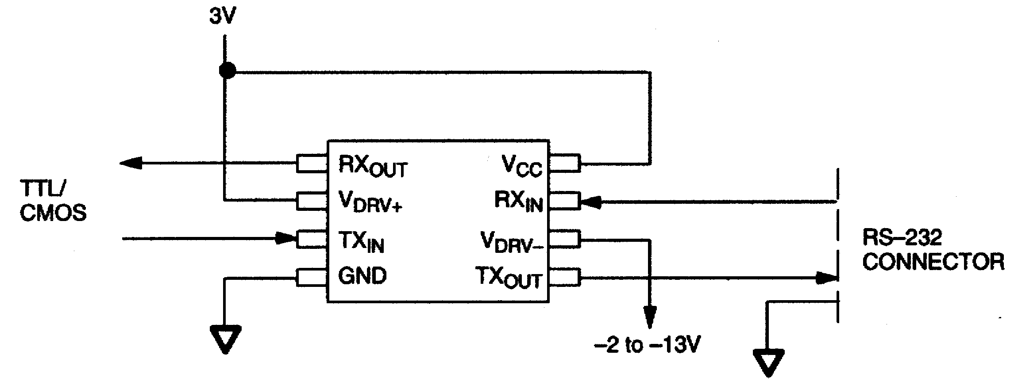

SINGLE 5V OPERATION Figure 3
(not true RS-232)
(See Note 1 and 3)
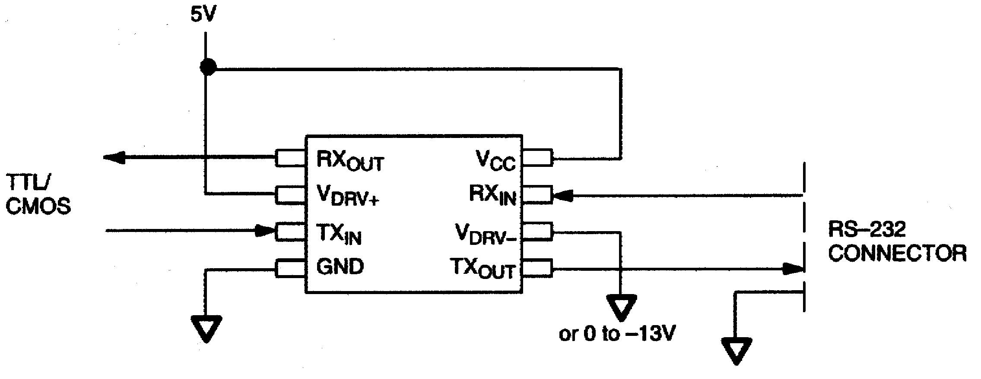

"STEALING" NEGATIVE SUPPLY Figure 4
(See Note 2)
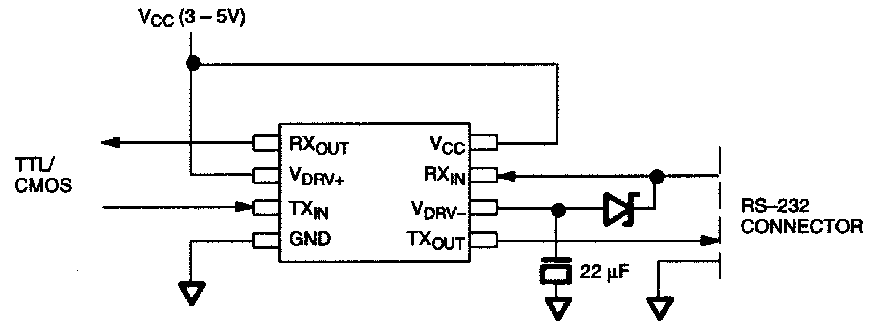
NOTES:
1. This circuit as shown does not meet the RS-232 requirement for signal levels (high-level output
voltage). However, as most RS-232 receivers will interpret any voltage over 2V as a space this will normally be of no consequence. Alternatively, VDRV+ can be supplied independently from a higher voltage supply.

2. The capacitor is charged negatively whenever RXIN is in a marking (or idle) state. When the DS276 is transmitting marking data and RXIN is spacing the capacitor will discharge towards ground with a time constant determined by the capacitor value and the value of the load resistance. The value shown should store sufficient charge for reliable operation up to 20 kbps.

3. RXIN must never be allowed to reach a negative voltage with respect to VDRV- or excessive currents will be drawn. Therefore, if negative voltage swings are present on RXIN, VDRV- should not be connected to ground and the circuit shown in Figure 4 should be used.
ABSOLUTE MAXIMUM RATINGS*
VCC -0.3V to +7.0V VDR+ -0.3V to +13V VDR- -13V to +0.3V RXIN -15V to +15V
TXIN -0.3V to VCC+0.3V TXOUT -15V to +15V RXOUT -0.3V to VCC+0.3V Operating Temperature 0°C to 70°C
Storage Temperature -55°C to +125°C Soldering Temperature 260°C for 10 seconds

* This is a stress rating only and functional operation of the device at these or any other conditions above those indicated in the operation sections of this specification is not implied. Exposure to absolute maximum rating conditions for extended periods of time may affect reliability.

RECOMMENDED DC OPERATING CONDITIONS (tA = 0°C to 70°C)
PARAMETER | SYMBOL | CONDITION | MIN | TYP | MAX | UNITS | NOTES
Logic Supply Voltage | VCC |  | 2.7 | 3-5 | 5.5 | V | 1
Transmit Driver Supply | VDR+  VDR+ | VCC=5V±10% VCC 2.7-3.6V | VCC  VCC | 5-12  3-5 | 13  5.5 | V V | 1  1
Transmit Driver Supply | VDR- |  | -15 |  | 0 | V | 1
High-level Input Voltage | VIH |  | 2 |  | VCC  +0.3 | V
Low-level Input Voltage | VIL |  | -0.3 |  | 0.8 | V
RXIN Input Voltage | VRS |  | -15 |  | +15 | V | 1

ELECTRICAL CHARACTERISTICS-3V OPERATION (tA = 0°C to 70°C)
PARAMETER | SYMBOL |  | MIN | TYP | MAX | UNITS | NOTES
Logic Supply Voltage | VCC |  | 2.7 |  | 3.6 | V
Dynamic Supply Current | IDRV1  ICC1  IDRV1  ICC1 | TXIN = VCC TXIN = VCC TXIN = GND TXIN = GND |  | 400  40  3.8  40 | 800  100  5  100 | uA uA mA uA | 2  2  2  2
Static Supply Current | IDRV2  ICC2  IDRV2  ICC2 | TXIN = VCC TXIN = VCC TXIN = GND TXIN = GND |  | 1.5  10  3.8  10 | 10  15  5  20 | uA uA mA uA | 3  3  3  3
Driver Leakage Current | IDRV3 | VCC = 0 |  | 0.05 | 1 | uA | 4
TXOUT Level High | VOTXH | VDRV+=VCC=  2.7V  VDRV-=0 | 2 | 2.4 |  | V | 5
TXOUT Level High | VOTXH | VDRV+=4.5V, VDRV-=-12V | 3.8 | 4 |  | V | 6

ELECTRICAL CHARACTERISTICS-3V OPERATION cont’d (TA = 0°C to 70°C)
PARAMETER | SYMBOL |  | MIN | TYP | MAX | UNITS | NOTES
TXOUT Level Low | VOTXL | VDRV += VCC=2.7V VDRV-=0 |  | 0.2 | 0.3 | V | 5
TXOUT Level Low | VOTXL |  |  | -11 | -10 | V | 6
TXOUT Short Circuit  Current | ISC | VDRV+ = 5.5V, VDRV- = -12V |  |  | 85 | mA | 7
TXOUT Output Slew Rate | tSR |  |  |  | 30 | V/us
Propagation Delay | tPD |  |  | 5 |  | us | 8
RXIN Input Threshold Low | VTL |  | 0.8 | 1.0 | 1.6 | V
RXIN Input Threshold  High | VTH |  | 1.2 | 2.0 | 2.4 | V
RXIN Threshold Hysteresis | VHYS |  | 0.4 | 1.0 |  | V | 9
RXOUT Output Current  High | IOH | VCC = 2.7V VOH = 2V |  |  | -0.5 | mA
RXOUT Output Current  Low | IOL | VCC = 2.7V VOL = 0.4V | 0.5 |  |  | mA

NOTES:
1. VDRV+ must be greater than or equal to VCC, RXIN must be greater than VDRV-.

2. See test circuit in Figure 5.

3. See test circuit in Figure 6.

4. See test circuit in Figure 7.

5. RL = 3kΩ to ground. Max data rate = 20k bps.

6. RL = 3kΩ to ground. Max data rate = 50k bps.

7. TXIN = VIL.

8. See test circuit in Figure 8.

9. VHYS = VTH - VTL.
+ELECTRICAL CHARACTERISTICS-5V OPERATION (tA = 0°C to 70°C)
PARAMETER | SYMBOL |  | MIN | TYP | MAX | UNITS | NOTES
Logic Supply Voltage | VCC |  | 4.5 | 5 | 5.5 | V
Dynamic Supply Current | IDRV1  ICC1  IDRV1  ICC1 | TXIN = VCC TXIN = VCC TXIN = GND TXIN = GND |  | 400  40  3.8  40 | 800  100  5  100 | uA uA mA uA | 1  1  1  1
Static Supply Current | IDRV2  ICC2  IDRV2  ICC2 | TXIN = VCC TXIN = VCC TXIN = GND TXIN = GND |  | 1.5  10  3.8  10 | 10  15  5  20 | uA uA mA uA | 2  2  2  2
Driver Leakage Current | IDRV3 | VCC = 0 |  | 0.05 | 1 | uA | 3
TXOUT Level High | VOTXH | VDRV+=VCC=  4.5V  VDRV-=0 | 3.3 | 3.8 |  | V | 4
TXOUT Level High | VOTXH | VDRV+=12V, VDRV-=-12V | 10 | 11 |  | V | 5
TXOUT Level Low | VOTXL | VDRV += VCC=12V VDRV-=12V |  | -11 | -10 | V | 4
TXOUT Level Low | VOTXL | VDRV+=VCC  VDRV-=0 |  | 0.2 | 0.3 | V | 5
TXOUT Short Circuit Current | ISC | VDRV+ = 12V, VDRV- = -12V |  |  | 85 | mA | 6
TXOUT Output Slew Rate | tSR |  |  |  | 30 | V/us
Propagation Delay | tPD |  |  | 5 |  | us | 7
RXIN Input Threshold Low | VTL |  | 0.8 | 1.2 | 6 | V
RXIN Input Threshold High | VTH |  | 1.6 | 2 | 2 | V
RXIN Threshold Hysteresis | VHYS |  | 0.5 | 0.8 |  | V | 8
RXOUT Output Current High | IOH | VCC = 4.5V VOH = 2.4V |  |  | -1 | mA
RXOUT Output Current Low | IOL | VCC = 4.5V VOL = 0.4V | 3 |  |  | mA

NOTES:
1. See test circuit in Figure 9.

2. See test circuit in Figure 10.

3. See test circuit in Figure 11.

4. RL = 3 kΩ to ground. Max data rate = 20 kbps.

5. RL = 3 kΩ to ground. Max data rate = 100 kbps.
6. TXIN = VIL.

7. See test circuit in Figure 12.

8. VHYS = VTH - VTL.

DYNAMIC OPERATING CURRENT TEST CIRCUIT Figure 5
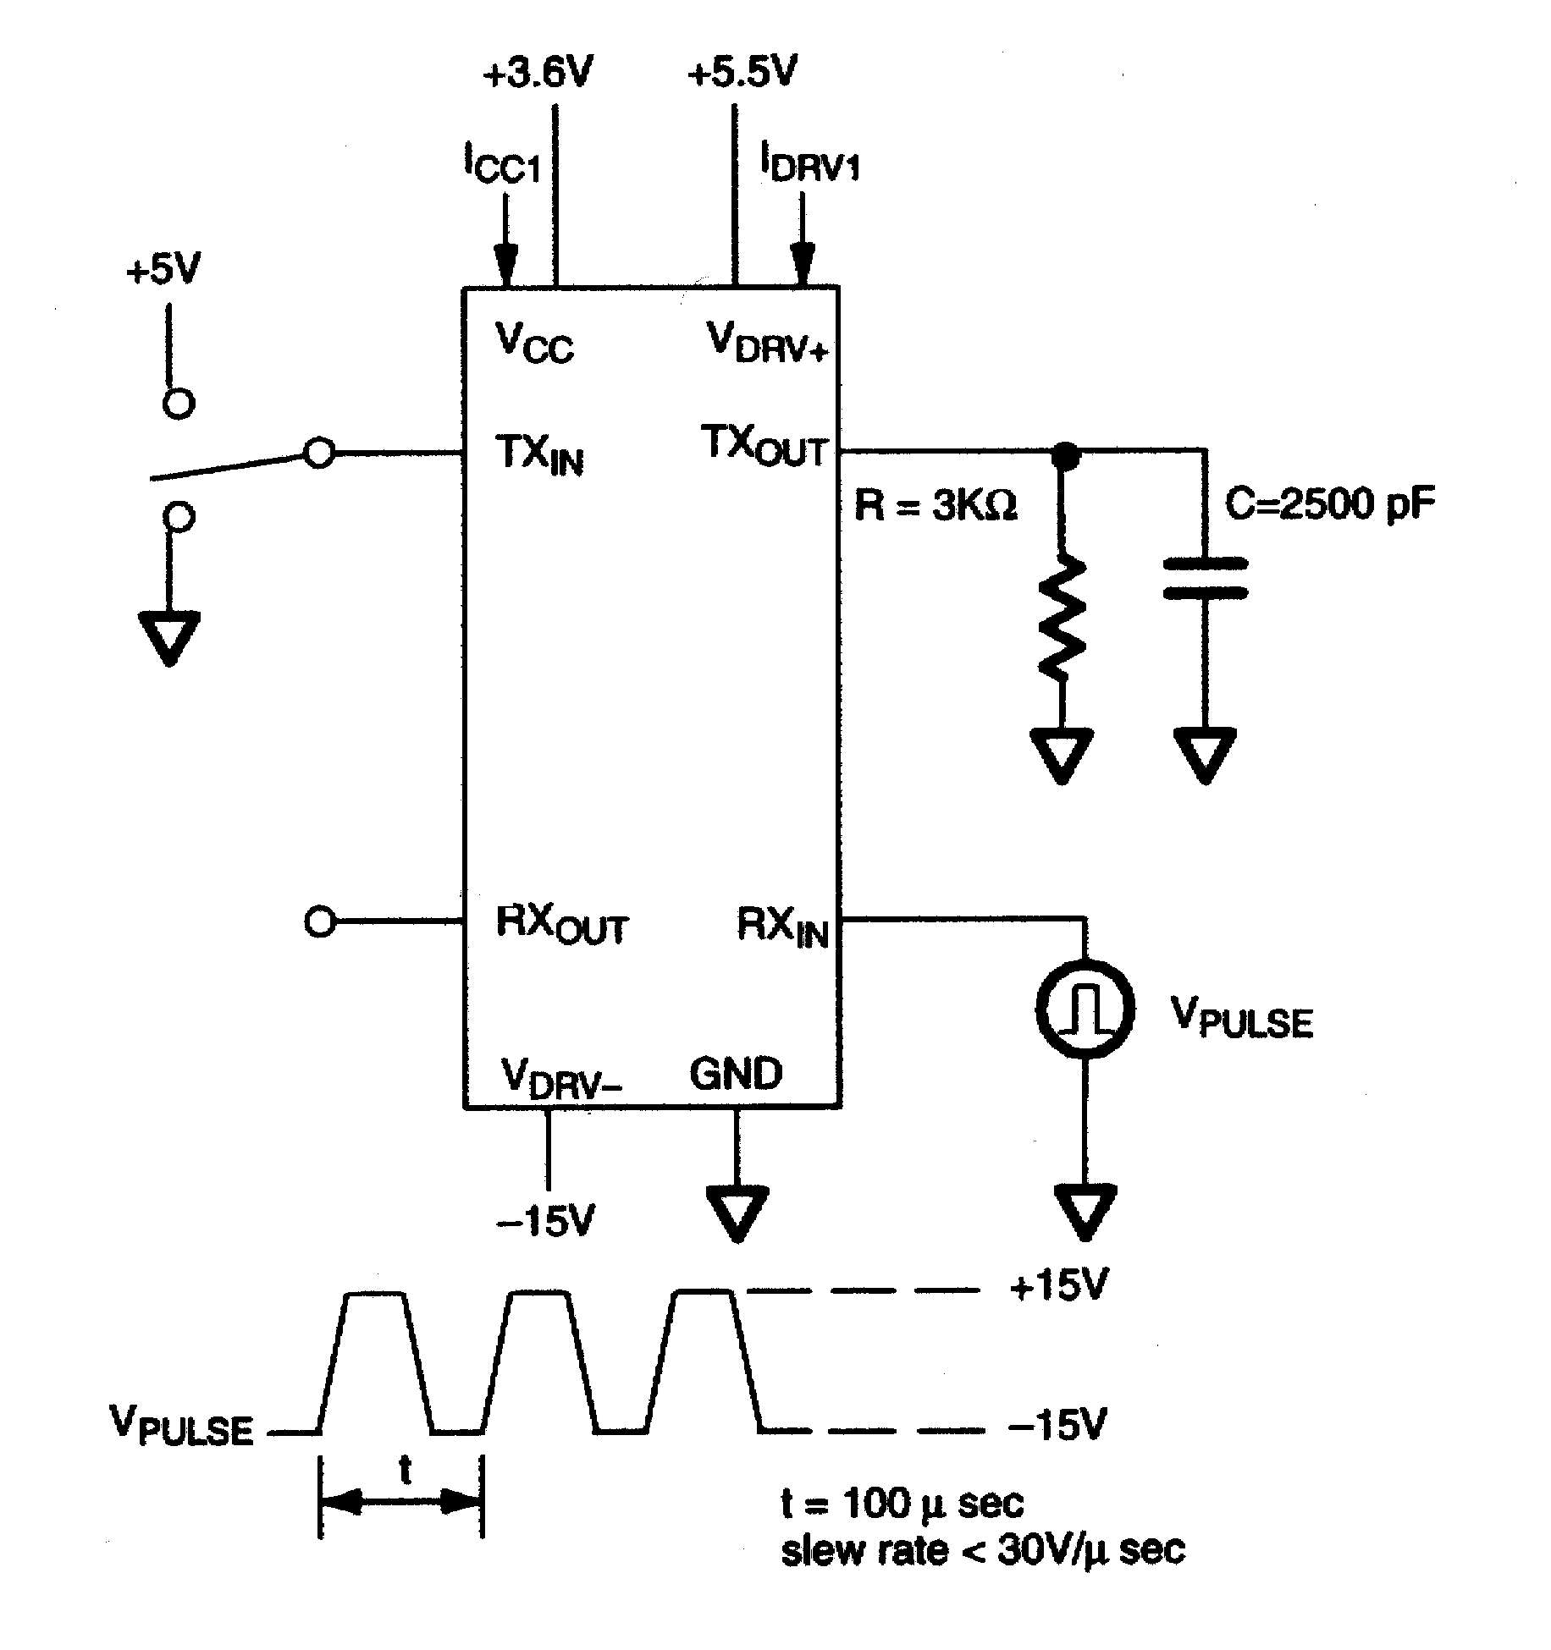

STATIC OPERATING CURRENT TEST CIRCUIT Figure 6
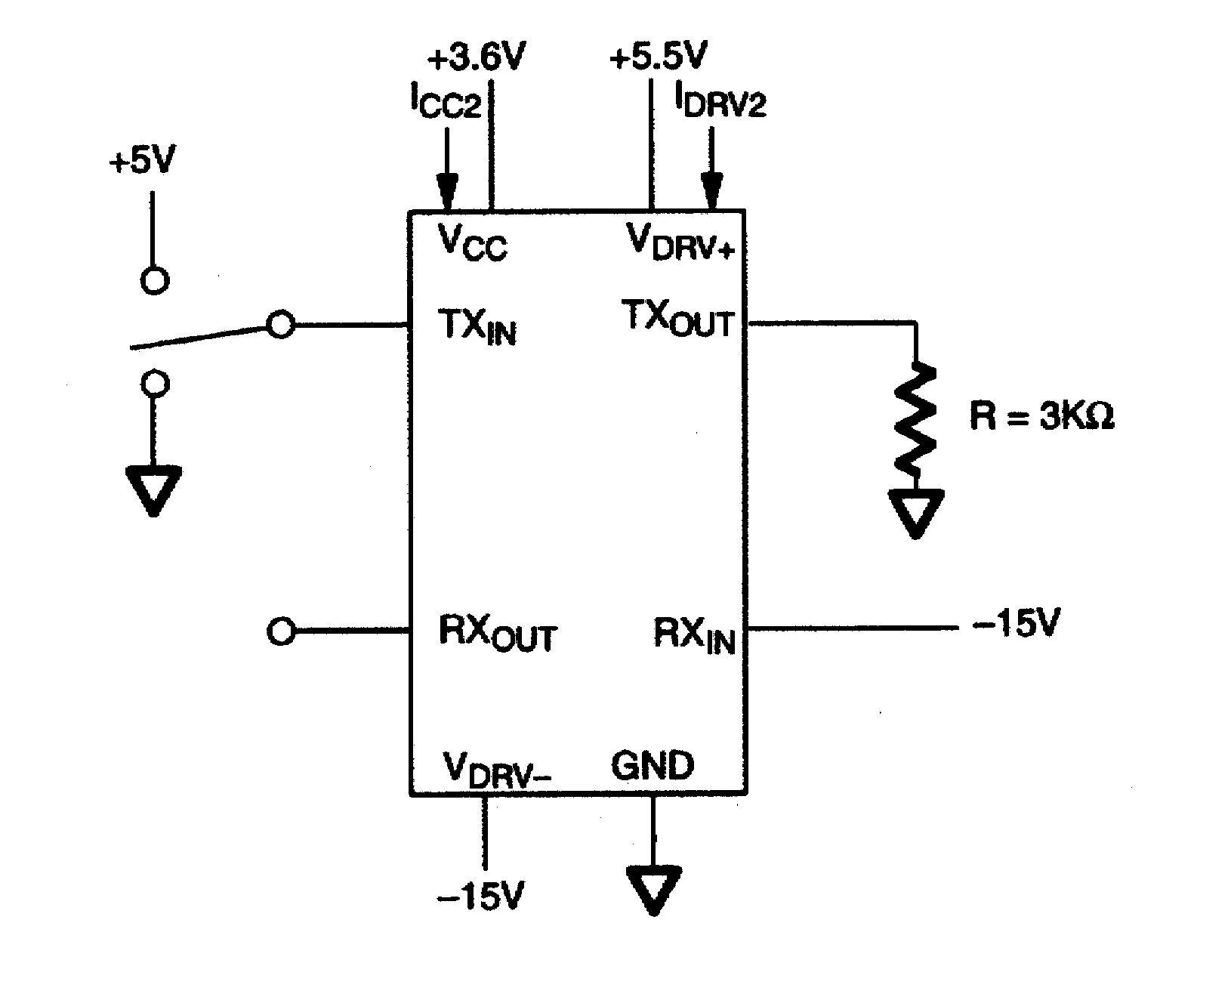
DRIVER LEAKAGE TEST CIRCUIT Figure 7

PROPAGATION DELAY TEST CIRCUIT Figure 8
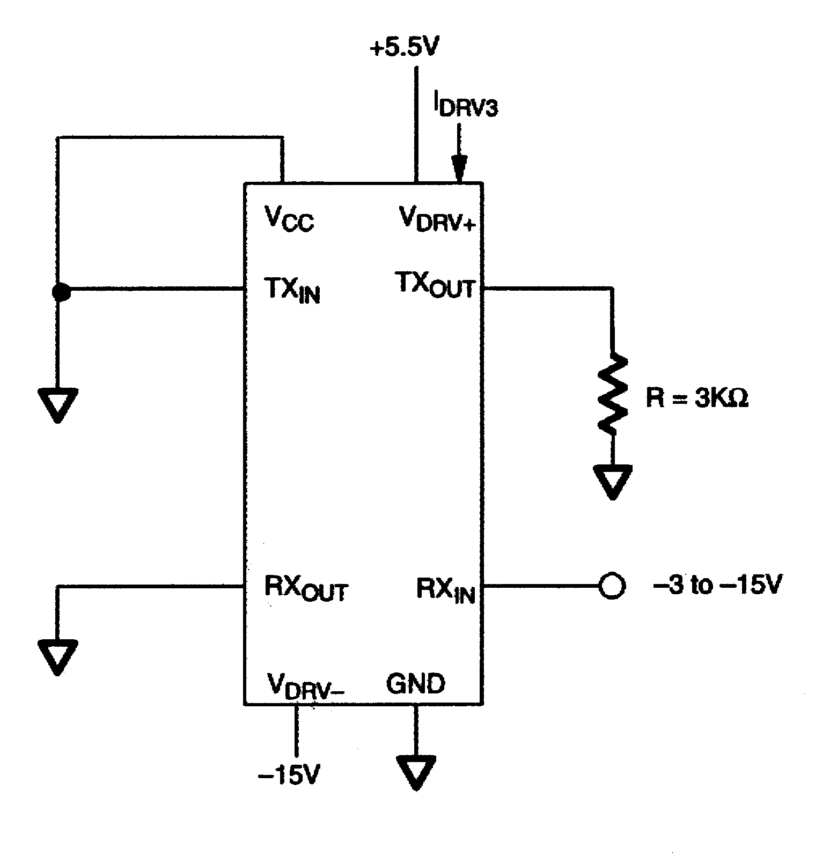

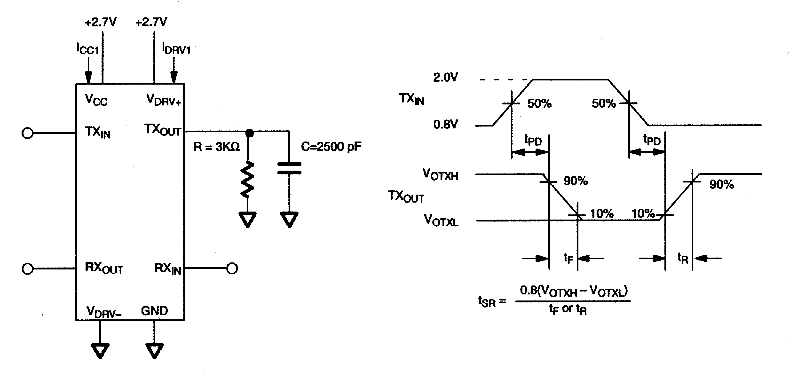

DYNAMIC OPERATING CURRENT TEST CIRCUIT Figure 9
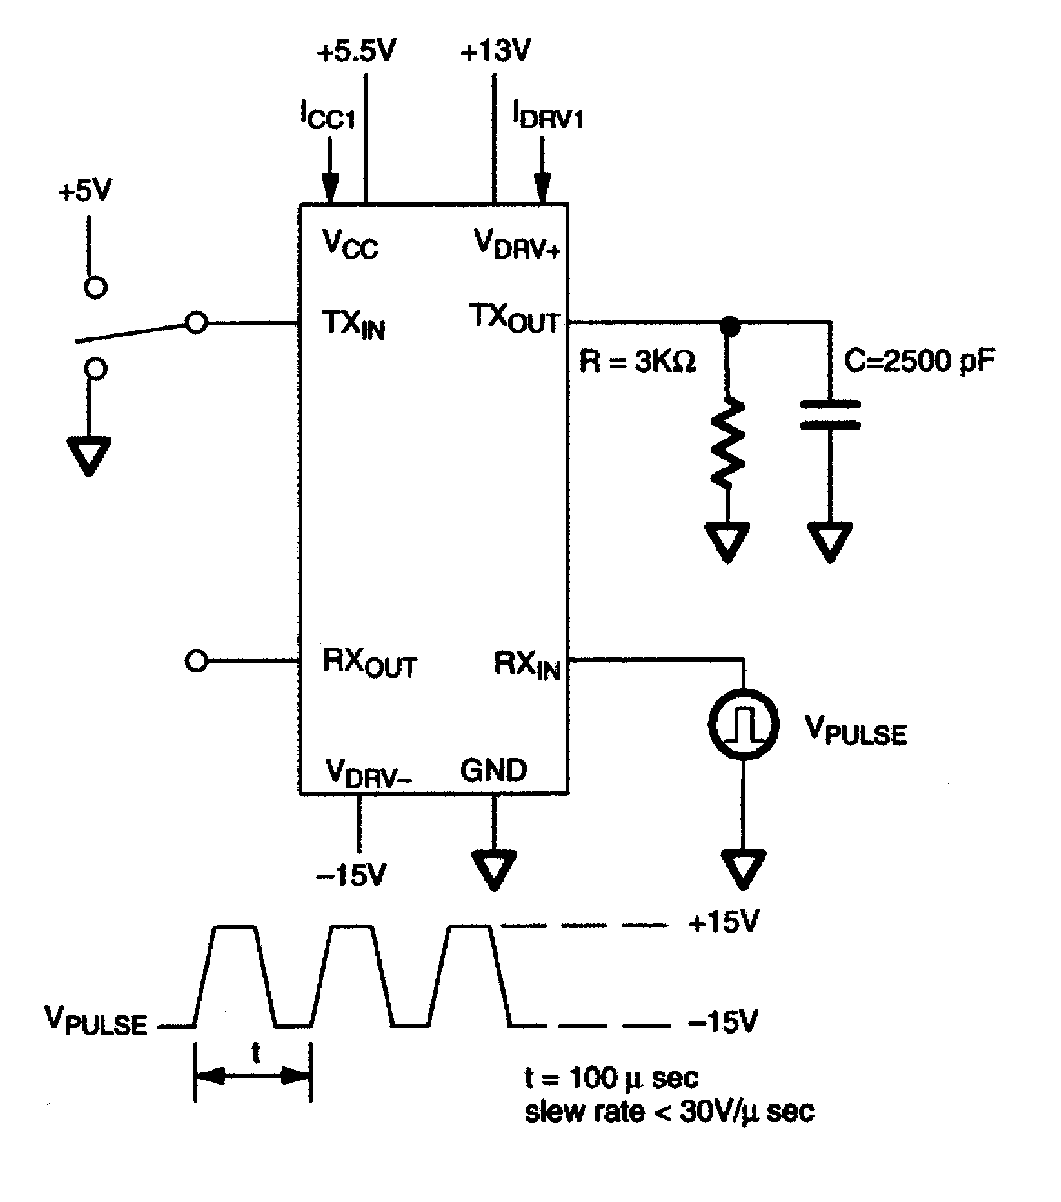
STATIC OPERATING CURRENT TEST CIRCUIT Figure 10

DRIVER LEAKAGE TEST CIRCUIT Figure 11
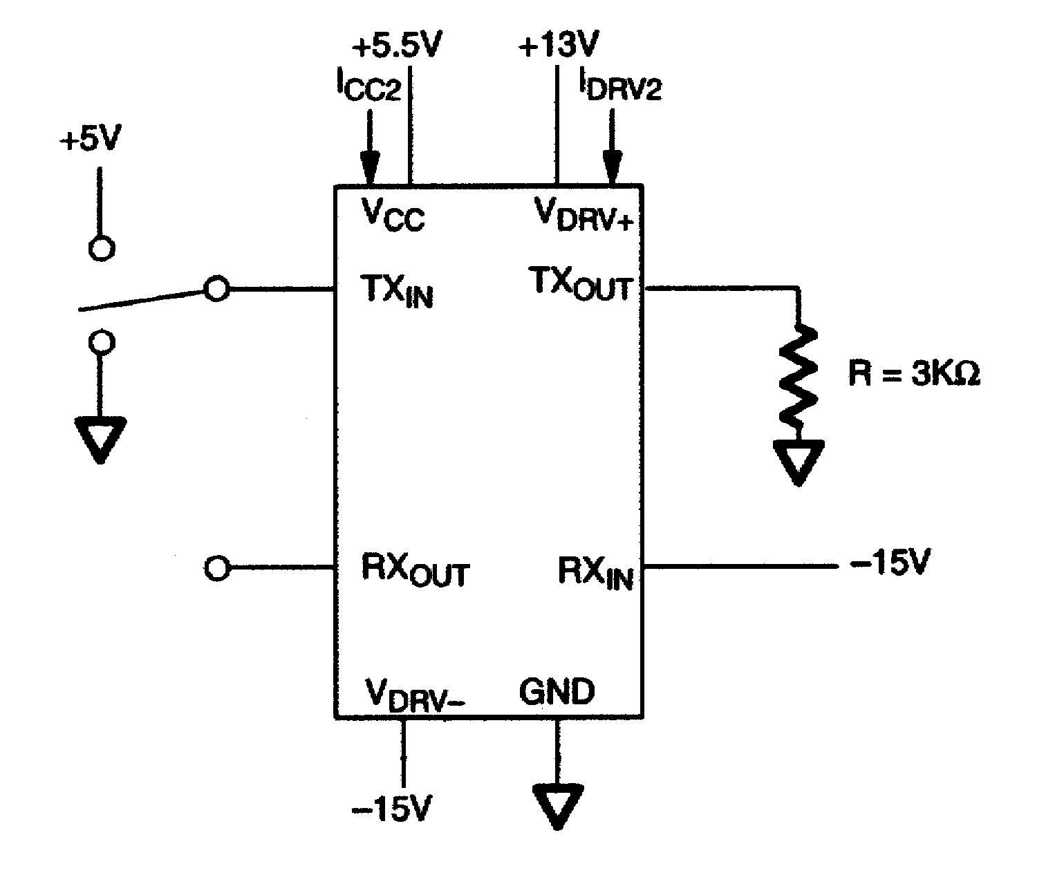

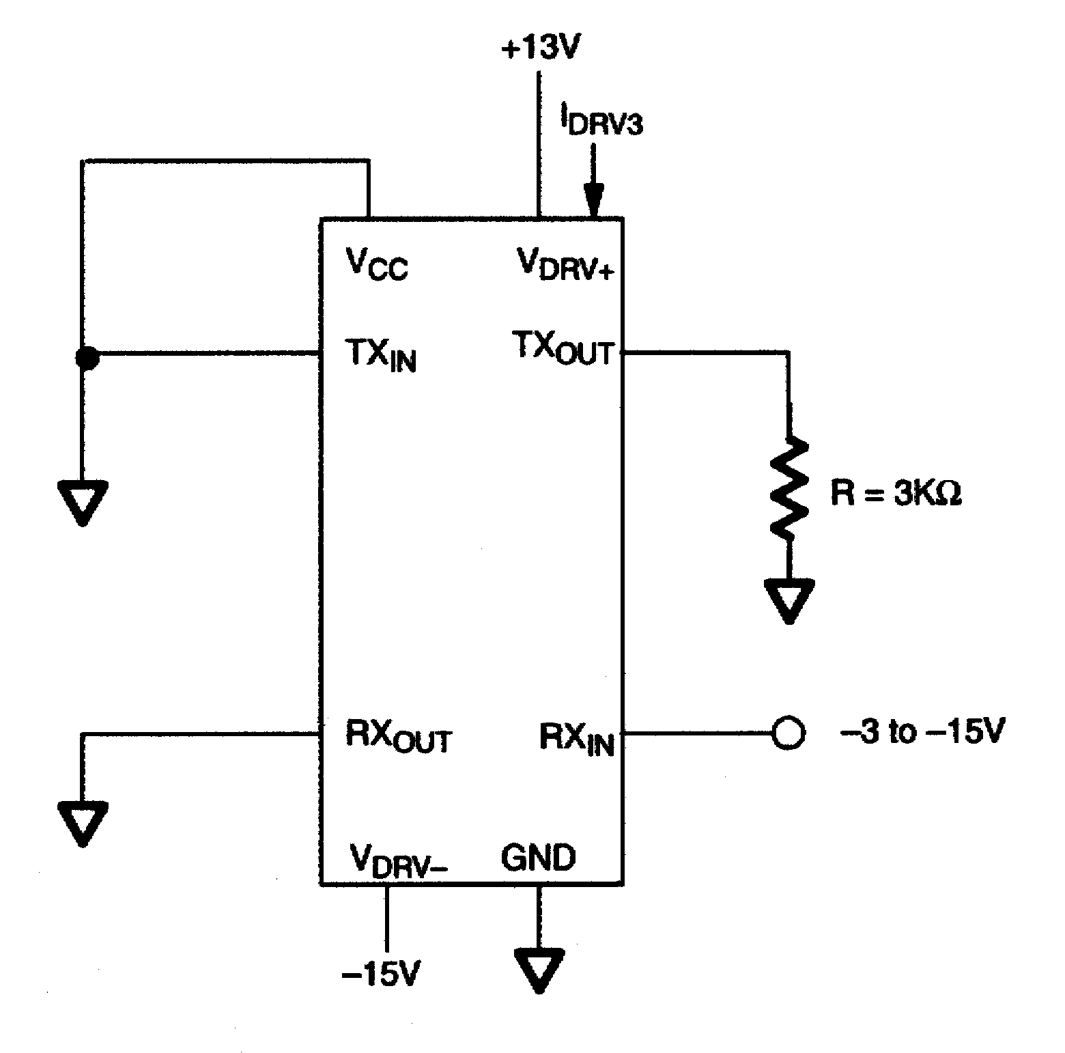

PROPAGATION DELAY TEST CIRCUIT Figure 12
