19-1146; Rev 3; 3/00

1.2A, Current-Limited, High-Side
P-Channel Switch with Thermal Shutdown

General Description
The MAX890L smart, low-voltage, P-channel, MOSFET power switch is intended for high-side load-switching applications. This switch operates with inputs from
+2.7V to +5.5V, making it ideal for both +3V and +5V systems. Internal current-limiting circuitry protects the input supply against overload. Thermal-overload pro- tection limits power dissipation and junction tempera- tures.
The MAX890L’s maximum current limit is 1.2A. The cur- rent limit through the switch is programmed with a resistor from SET to ground. The quiescent supply cur- rent is a low 10µA. When the switch is off, the supply current decreases to 0.1µA.
The MAX890L is available in an 8-pin SO package.
Features
♦ +2.7V to +5.5V Input Range
♦ Programmable Current Limit
♦ Low Quiescent Current
10µA (typ) at VIN = +3.3V
0.1µA (typ) with Switch Off
♦ Thermal Shutdown
♦ FAULT Indicator Output
♦ 0.09Ω (typ) On-Resistance

Applications
Ordering Information

PCMCIA Slots
Access Bus Slots

PART*

TEMP. RANGE

PIN- PACKAGE

CURRENT LIMIT

Portable Equipment
MAX890LC/D 0°C to +70°C
Dice**
1.2A

MAX890LESA -40°C to +85°C 8 SO
1.2A

* To order this unit in tape and reel, add (-T) to the end of the part number.
** Dice are tested at TA = +25°C.

Typical Operating Circuit
Pin Configuration

TOP VIEW

INPUT

IN

IN
100kΩ

MAX890L

OUT OUT

OUTPUT
0.1µF

IN 1

IN 2

MAX890L

8 FAULT

7 OUT

1µF
FAULT ON ON/OFF

GND SET
ON 3

GND 4
6 OUT

5 SET

MAX890L
RSET
SO

ABSOLUTE MAXIMUM RATINGS
IN to GND ................................................................-0.3V to +6V ON, FAULT to GND .................................................-0.3V to +6V SET, OUT to GND ...................................... -0.3V to (VIN + 0.3V) Maximum Continuous Switch Current ..................................1.5A Continuous Power Dissipation (TA = +70°C)
SO (derate 5.88mW/°C above +70°C) ..........................471mW

Operating Temperature Range
MAX890LESA ....................................................-40°C to +85°C Storage Temperature Range ........................... -65°C to +150°C Lead Temperature (soldering, 10s) . ...............................+300°C

MAX890L
Stresses beyond those listed under “Absolute Maximum Ratings” may cause permanent damage to the device. These are stress ratings only, and functional operation of the device at these or any other conditions beyond those indicated in the operational sections of the specifications is not implied. Exposure to absolute maximum rating conditions for extended periods may affect device reliability.

ELECTRICAL CHARACTERISTICS
(VIN = +3V, TA = 0°C to +85°C, unless otherwise noted. Typical values are at TA = +25°C.)

µs
PARAMETER | CONDITIONS | MIN TYP MAX | UNITS
Operating Voltage |  | 2.7 5.5 | V
Quiescent Current | VIN = 5V, ON = GND, IOUT = 0 | 13 20 | µA
Off-Supply Current | ON = IN, VIN = VOUT = 5.5V | 0.03 1 | µA
Off-Switch Current | ON = IN, VIN = 5.5V, VOUT = 0 | 0.04 15 | µA
Undervoltage Lockout | Rising edge, 1% hysteresis | 2.0 2.4 2.6 | V
On-Resistance | VIN = 4.5V | 75 130 | mΩ
On-Resistance | VIN = 3.0V | 90 150 | mΩ
Current-Limit-Amplifier Threshold | VSET required to turn the switch off (Note 1) | 1.178 1.240 1.302 | V
Maximum Output Current Limit |  | 1.2 | A
IOUT to ISET Current Ratio | IOUT = 500mA, VOUT > 1.6V | 970 1110 1300 | A/A
ON Input Low Voltage | VIN = 2.7V to 5.5V | 0.8 | V
ON Input High Voltage | VIN = 2.7V to 3.6V | 2.0 | V
ON Input High Voltage | VIN = 4.5V to 5.5V | 2.4 | V
ON Input Leakage Current | V ON = 5.5V | 0.01 1 | µA
ISET Bias Current | VSET = 1.24V, IOUT = 0; VIN = VOUT | 0.5 3 | µA
FAULT Logic Output Low Voltage | ISINK = 1mA, VSET = 1.4V | 0.4 | V
FAULT Logic Output High Leakage Current | V FAULT = 5.5V, VSET = 1V | 0.05 1 | µA
Slow-Current-Loop Response Time | 20% current overdrive, VCC = 5V | 5 | µs
Fast-Current-Loop Response Time |  | 2 | µs
Turn-On Time | VIN = 5V, IOUT = 500mA | 120 200
Turn-On Time | VIN = 3V, IOUT = 500mA | 185
Turn-Off Time | VIN = 5V | 2 5 | µs

MAX890L

ELECTRICAL CHARACTERISTICS
(VIN = +3V, TA = -40°C to +85°C, unless otherwise noted.) (Note 2)

PARAMETER | CONDITIONS | MIN TYP MAX | UNITS
Operating Voltage |  | 3.0 5.5 | V
Quiescent Current | VIN = 5V, ON = GND, IOUT = 0 | 50 | µA
Off-Supply Current | ON = IN, VIN = VOUT = 5.5V | 2.2 | µA
Off-Switch Current | ON = IN, VIN = 5.5V, VOUT = 0 | 15 | µA
Undervoltage Lockout | Rising edge, 1% hysteresis | 2.0 2.9 | V
On-Resistance | VIN = 4.5V | 130 | mΩ
On-Resistance | VIN = 3.0V | 150 | mΩ
Current-Limit-Amplifier Threshold | VSET required to turn the switch off (Note 1) | 1.14 1.34 | V
IOUT to ISET Current Ratio | IOUT = 500mA, VOUT > 1.6V | 925 1390 | A/A
FAULT Logic Output Low Voltage | ISINK = 1mA, VSET = 1.4V | 0.4 | V
Turn-On Time | VIN = 5V | 200 | µs
Turn-Off Time | VIN = 5V | 1 20 | µs

Note 1: Tested with IOUT = 100mA and VSET raised until VIN - VOUT ≥ 0.8V.
Note 2: Specifications to -40°C are guaranteed by design, not production tested.

Typical Operating Characteristics
(TA = +25°C, unless otherwise noted.)

QUIESCENT CURRENT
vs. INPUT VOLTAGE
14
MAX890 toc01

12 ON = GND IOUT = 0
10
QUIESCENT CURRENT
vs. TEMPERATURE
14

13
QUIESCENT CURRENT (µA)

12

100
MAX890 toc02

10
OFF-SUPPLY CURRENT
vs. TEMPERATURE
MAX890 toc03

8 11
1
6 10

4 9
0.1
OFF-SUPPLY CURRENT (nA)
2 8

0
0 1 2 3 4 5 6

7
-40 -20 0
VIN = 5V
VIN = 3V

20 40

60 80

100

0.01

-40 -20 0

20 40 60

80 100

1000

100
OFF-SWITCH CURRENT (nA)

10
INPUT VOLTAGE (V)

OFF-SWITCH CURRENT
vs. TEMPERATURE

1.3
MAX890 toc04

1.2

1.1
NORMALIZED RON

1.0
TEMPERATURE (°C)

NORMALIZED ON-RESISTANCE
MAX890 toc05
vs. TEMPERATURE

IOUT = 1/2ILIMIT

1400

1200

1000
IOUT/ISET RATIO

800
TEMPERATURE (°C)

IOUT/ISET RATIO
MAX890 toc06
vs. ILIMIT

1 0.9
600

0.1

0.8

0.7

400

200

0.01

-40

-20

0 20 40

60 80

100

0.6

-40 -20 0

20 40

60 80

100

0
0 20 40

60 80

100 120

140

TEMPERATURE (°C)
TEMPERATURE (°C)
ILIMIT (%)

1.2

1.0
NORMALIZED OUTPUT CURRENT

0.8

0.6

0.4

0.2

0
ILIMIT
VIN = 5V

NORMALIZED OUTPUT CURRENT
vs. OUTPUT VOLTAGE

260
MAX890 toc07

240

220

200
180
tON (µs)

160
140

120
100

80
60
TURN-ON TIME
vs. TEMPERATURE
MAX890 toc08

ILOAD = ILIMIT

VIN = 3V

VIN = 5V
TURN-OFF TIME
vs. TEMPERATURE
MAX890 toc09
8
ILOAD = ILIMIT
7

6

5
tOFF (µs)

4

3

2

1

0

VIN = 5V

VIN = 3V

0 1 2 3 4 5 6
-40 -20 0
20 40
60 80
100
-40 -20 0
20 40
60 80
100

OUTPUT VOLTAGE (V)
MAX890L

QUIESCENT CURRENT (µA)
TEMPERATURE (°C)
TEMPERATURE (°C)

Typical Operating Characteristics (continued)
(TA = +25°C, unless otherwise noted.)

OUTPUT OVER-LOAD (SLOW LOOP RESPONSE)

MAX890 toc10
OUTPUT SHORT-CIRCUIT (FAST LOOP RESPONSE)

MAX890 toc11
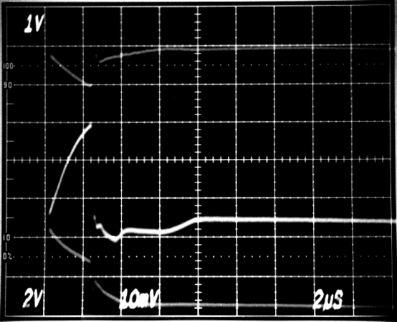

A 5V
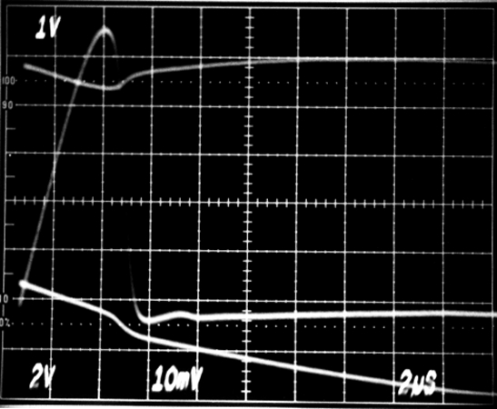

B
A 5V

B

C

0V, 0A

2µs/div
CIN = 100µF, COUT = 0.1µF A: VIN, 1V/div, AC-COUPLED

B: IOUT, 1A/div
C: VOUT, 2V/div
0A

C

0V
2µs/div
CIN = 100µF, COUT = 0.1µF A: VIN, 1V/div, AC-COUPLED

B: IOUT, 5A/div
C: VOUT, 2V/div

LOAD-TRANSIENT RESPONSE

MAX890 toc12
SWITCH TURN-ON TIME

MAX890 toc13
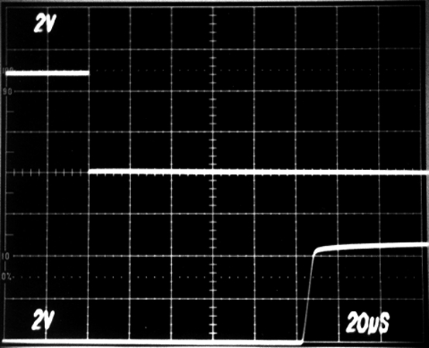

A A
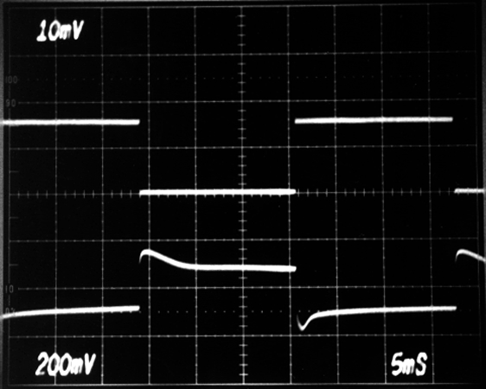

0A

0V

B B

VIN = 5V
A: IOUT = 0mA TO 750mA,
0.5A/div
5ms/div

B: VOUT RIPPLE,
200mV/div, AC COUPLED

SWITCH TURN-OFF TIME

MAX890 toc14
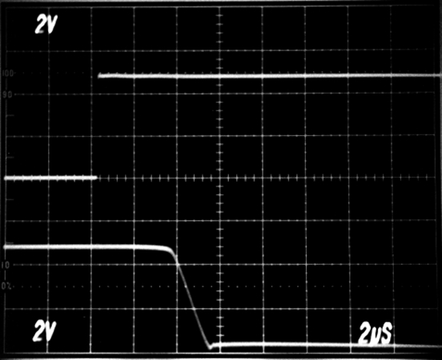

VIN = 5V, IOUT = ILIMIT
A: VON, 2V/div
B: VOUT, 2V/div
20µs/div

A

0V

B

MAX890L
0V

VIN = 5V, IOUT = ILIMIT
A: VON, 2V/div
B: VOUT, 2V/div

2µs/div

Pin Description

PIN | NAME | FUNCTION
1, 2 | IN | Input. P-channel MOSFET source. Bypass IN with a 1µF capacitor to ground.
3 | ON | Active-Low Switch On Input. A logic low turns the switch on.
4 | GND | Ground
5 | SET | Set Current-Limit Input. A resistor from SET to ground sets the current limit for the switch. RSET = 1.38 x 103 / ILIMIT, where ILIMIT is the desired current limit in amperes.
6, 7 | OUT | Switch Output. P-channel MOSFET drain. Bypass OUT with a 0.1µF capacitor to ground.
8 | FAULT | Fault-Indicator Output. This open-drain output goes low when in current limit or when the die temperature exceeds +135°C.

Detailed Description
The MAX890L P-channel MOSFET power switch limits output current to a programmed level. When the output current is increased beyond the programmed current limit, or 1.2A (IMAX), the current also increases through the replica switch (IOUT/1110) and through RSET (Figure 1). The current-limit error amplifier compares the voltage across RSET to the internal +1.24V refer- ence, and regulates the current back to the lesser of the programmed limit (ILIMIT) or 1.2A.
This switch is not bidirectional; therefore, the input volt- age must be higher than the output voltage.

Setting the Current Limit

IN FAULT
N

P

P

REPLICA AMPLIFIER

MAX890L

ON

P

SET

OUT

The MAX890L features internal current-limiting circuitry with a maximum programmable value (IMAX) of 1.2A. For best performance, set the current limit (ILIMIT) between 0.2 IMAX ≤ ILIMIT ≤ IMAX. This current limit remains in effect throughout the input supply-voltage range.
Program the current limit with a resistor (RSET) from ON

CONTROL
ON CURRENT-LIMIT
AMPLIFIER
1.24V HOT

RSET

GND

SET to ground (Figure 2) as follows:
MAX890L
ISET = ILIMIT / 1110
RSET = 1.24V / I8 = 1.38 x 103 / ILIMIT
where ILIMIT is the desired current limit.

Short-Circuit Protection The MAX890L is a short-circuit-protected switch. In the event of an output short circuit or current-overload con- dition, the current through the switch is limited by the internal current-limiting error amplifier to 1.5 x ILIMIT. When the fault condition is removed, the replica error amplifier will set the current limit back to ILIMIT.
CIRCUITRY

Figure 1. Functional Diagram

For a high dVDS/dt during an output short-circuit condi- tion, the switch turns off and disconnects the input supply from the output. The current-limiting amplifier then slow- ly turns the switch on with the output current limited to
1.5 x ILIMIT. When the fault condition is removed, the current limit is set back to ILIMIT. Refer to Output Short- Circuit Fast-Loop Response and Output Over-Load

MAX890L

Figure 2. Setting the Current Limit

SET

GND

RSET
most applications; however, higher capacitor values will further reduce the voltage drop at the input.

Output Capacitor Connect a 0.1µF capacitor from OUT to GND. One function of this capacitor is to prevent inductive para- sitics from pulling OUT negative during turn-off.

Layout and Thermal-Dissipation
Consideration To take full advantage of the switch-response time to output short-circuit conditions, it is very important to keep all traces as short as possible to reduce the effect of undesirable parasitic inductance. Place input and output capacitors as close as possible to the device (no more than 5mm).
Under normal operating conditions, the package can dissipate and channel heat away. Calculate the maxi- mum power as follows:

Slow-Loop Response in the Typical Operating
MAX890L
Characteristics.

Thermal Shutdown The MAX890L features thermal shutdown. The switch turns off when the junction temperature exceeds
+135°C. Once the device cools by 10°C, the switch turns back on. If the fault short-circuit condition is not removed, the switch will cycle on and off, resulting in a pulsed output.

Fault Indicator The MAX890L provides a fault output (FAULT). This open-drain output goes low when in current limit or when the die temperature exceeds +135°C. A 100kΩ pull-up resistor from FAULT to IN provides a logic- control signal.
Applications Information

Input Capacitor To limit the input voltage drop during momentary output short-circuit conditions, connect a capacitor from IN to GND. A 1µF ceramic capacitor will be adequate for
P = I2LIMIT x RON
where RON is the on-resistance of the switch.
When the output is short circuited, the voltage drop across the switch equals the input supply. Hence, the power dissipated across the switch increases, as does the die temperature. If the fault condition is not removed, the thermal-overload-protection circuitry turns the switch off until the die temperature falls by 10°C. A ground plane in contact with the device will help dissi- pate additional heat.
Chip Information
TRANSISTOR COUNT: 396

MAX890L

Maxim cannot assume responsibility for use of any circuitry other than circuitry entirely embodied in a Maxim product. No circuit patent licenses are implied. Maxim reserves the right to change the circuitry and specifications without notice at any time.

SOICN.EPS

8 Maxim Integrated Products, 120 San Gabriel Drive, Sunnyvale, CA 94086 408-737-7600

© 2000 Maxim Integrated Products Printed USA is a registered trademark of Maxim Integrated Products.

